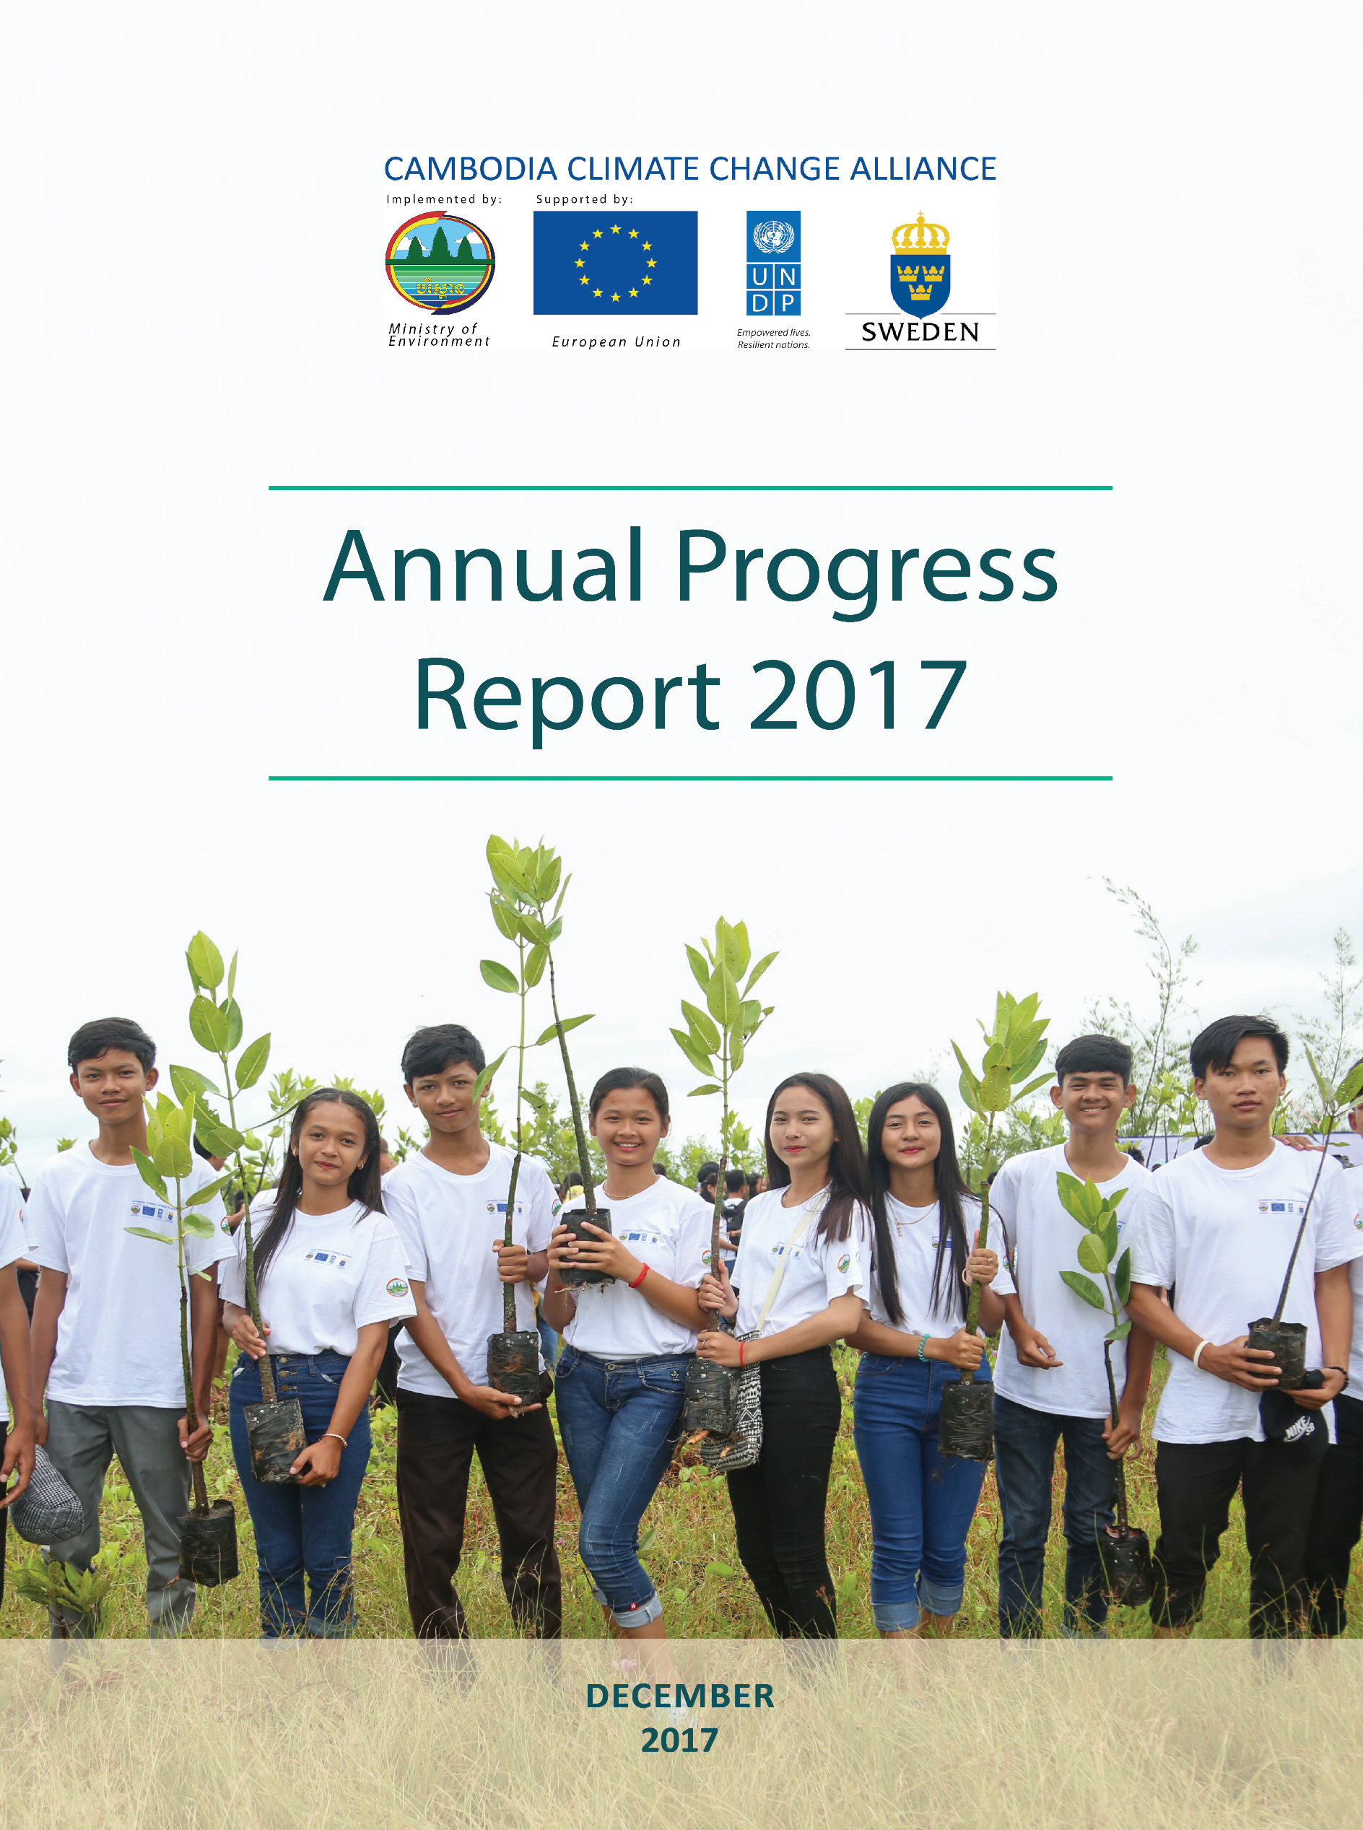

Front Page: Youth planted the mangroves tree at Koh Kong Province
Photo by: CCCA

Contact Information
Department of Climate Change, General Secretariat of the National Council for Sustainable Development / Ministry of Environment
No. 503, Road along Bassac River, Sangkat Tonle Bassac, Chamkarmon, Phnom Penh, Cambodia
Phone/Fax: (855-23) 218 370 | email: cceap@online.com.kh | http://www.camclimate.org.kh

PROJECT SUMMARY

PROJECT TITLE: Cambodia Climate Change Alliance –Phase II (CCCA)

ORGANISATION: Department of Climate Change, General Secretariat of the National Council for Sustainable Development, Ministry of Environment

REPORTING PERIOD: 1st Jan 2017 to 31th December 2017

PROJECT DURATION: 1st July 2014 to 30th June 2019

TOTAL APPROVED BUDGET: US$ 11,129,388.00

CONTENTS

PROJECT SUMMARY i
CONTENTS ii
List of Figures iii
List of Tables iii
List of Tables iii
ACRONYMS AND ABBREVIATIONS v
Executive Summary 1
I. Implementation Progress 3
Result 1: Strengthening the governance of climate change 3
Result 2: Domestic and external finance effectively oriented in support of climate resilient, and low carbon development 23
Result 3: Strengthened human and technological capacities to support climate change response 29
Project Monitoring and Evaluation 45
Capacity Development 45
Gender mainstreaming 46
Environment and social safeguards 46
Innovation 46
Lessons Learned 47
Log Frame Analysis 47
II. Project implementation challenges 57
Project issues 57
Risk log (See Annex I) 57
III. Financial Status and Utilization 58
I. Supporting documents 59
II. Work-Plan for 2018 50
Annex I: Risk Log 54

List of Figures
Figure 1: Update of Institutional Readiness Indicators in 2017 8
Figure 2: Participants in international meetings and training 9
Figure 3: Sources of climate change public expenditure (CPER 2016, MEF) 23
Figure 4: Annual website visits from 2013 to 2017 29
Figure 5: Number of participants in climate change trainings for youth and under-graduated students for 2017 43

List of Tables
Table 1: Selected communes 5
Table 2: Climate Change projects presented in 12 CIPs 5
Table 3: List of CIP supported by CCCA 6
Table 4: Institutional Readiness indicators in 2014 and 2017 7
Table 5: List of Grantee in window I round 1 and round 2 10
Table 6: Status of CCCA grants 7
Table 7: Status of core indicators and targets of CCCA grants for Window 1 Round 1 & Round 2 21
Table 8: Schedule of spot checks conducted. 22
Table 9: Summary of financial management of CCCA grantees under Window01. 22
Table 10: Summary of significant achievements for grants under Window 2: 26
Table 11: Summary of financial management of CCCA grantees under Window 2: 29
Table 12: List of area for cooperation under LoA with universities 31
Table 13: List of approved projects under CCCA Grant Facility Window 3 32
Table 14: Status of achievement of grantee under window 3 33
Table 15: Status of core indicators and targets of CCCA Research and Innovation grants for Window 3 41
Table 16: Summary of financial management of CCCA grantees under Window03. 42
Table 17: Contribution Overview 56
Table 18: Annual Expenditure by Result [1Jan - 31 Dec 2017] 57
Table 19: Cumulative Expenditure by Result [1Jul 2014- 31 Dec 2017] 57

List of Photos
Photo 1: Second NCSD meeting chaired by H.E Say Samal, Minister of Environment and Chair of NCSD 3
Photo 2: CC mainstreaming into commune development plan exercise at Siem Reap Province 4
Photo 3: CCCA support CIP Project at Oddar Meanchey on Water storage 6
Photo 4: CCCA support CIP Project at Takeo on Solar light at school 6
Photo 5: CC WTG meeting with DPs 22
Photo 6:MoU signing ceremony GSSD and university on Sustainable Development 30
Photo 7: CC Video talk shop at Television of Kampuchea 41
Photo 8: CC Training for youth at Kos Kong Province 42

ACRONYMS AND ABBREVIATIONS
ADB | Asian Development Bank
CCAP | Climate Change Action Plan
CCCA | Cambodia Climate Change Alliance
CCCA-TFS | Cambodia Climate Change Alliance Trust Fund Secretariat
CCCSP | Cambodia Climate Change Strategic Plan
CDC/CRDB | Council for the Cambodia Development/Cambodia Rehabilitation and Development Board
CDP | Commune Development Plan
CPEIR | Climate Change Public Expenditure Institutional Review
CCSAP | Climate Change Strategy and Action Plan
CCTWG | Climate Change Technical Working Group
COP21 | Conference of Parties 21
CPA | Community Protected Area
CSOs | Civil Society Organizations
DCC | Department of Climate Change
EU | European Union
EU ROM | European Union Results Oriented Monitoring
EFI | Economic and Finance Institute
GDA | General Department of Agriculture
GSSD | General Secretariat of NCSD
HACT | Harmonized Approach to Cash Transfer
IIED | International Institute for Environment and Development
INC | Initial National Communication
KAP | Knowledge Attitude Practice
LDCF | Least Developed Countries Fund
LoA | Letter of Agreement
MAFF | Ministry of Forestry and Fisheries
M&E | Monitoring and Evaluation
MIME | Ministry of Industry, Mine and Energy
MTR | Mid Term Review
MoE | Ministry of Environment
MoEYS | Ministry of Education, Youth and Sport
MoPWT | Ministry of Public Works and Transport
MoRD | Ministry of Rural Development
MoT | Ministry of Tourism
MoInf | Ministry of Information
MOWA | Ministry of Women Affair
MOWRAM | Ministry of Water Resource and Meteorology
MLMUPC | Ministry of Land Management, Urban Planning and Construction
MRC | Mekong River Commission
NAPA | National Action Plan for Adaptation to Climate Change
NAP | National Adaptation Plan
NCCC | National Climate Change Committee
NCDD-S | The National Committee for Sub-National Democratic Development
NCSD | National Council for Sustainable Development
NCDM | National Committee for Disaster Management
NSDP | National Strategic Development Plan
ODA | Official Development Assistance
POC | Priority Operating Cost
PPCR | Pilot Project for Climate Resilience
PSB | Programme Support Board
RGC | Royal Government of Cambodia
REDD+ | Reducing Emissions from Deforestation and Forest Degradation
SNAs | Sub-National Administration
SNC | Second National Communication
SNIF | Sub-National Investment Fund
SBSTA | Subsidiary Body for Scientific and Technological Advice
UN | United Nation
UNDP | United Nations Development Programme
UNFCCC | United Nations Framework Convention on Climate Change
UNEP | United Nations Environment Programme
UNITAR | United Nations Institute for Training and Research
WOMEN | Women Organization for Modern Economy and Nursing

Executive Summary

Key achievements for this reporting period are as follows:
- The Climate Change Technical Working Group (CC-TWG) was officially established by the Prakas of the Minister of Environment and Chair of the National Council for Sustainable Development (NCSD) on May 05, 2017. CCTWG is chaired by H.E Chuop Paris, Deputy Secretary General, GSSD/NCSD and is composed of 25 members from 19 ministries and government institutions, with the Director of Department of Climate Change (DCC), GSSD/NCSD and the Director of Department of Marine and Coastal Zone Conservation, Ministry of Environment serving respectively as CCTWG’s first and second vice-chairs. CCTWG meetings were conducted 2 times in 2017 to discuss M&E matters, including the update of national M&E framework indicators, localization exercise for SDG goal 13, and CCAP reporting mechanism.

- A coordination mechanism with Development Partners has also been operationalized, with six-monthly meetings between the CCTWG and Development Partners held in June and November 2017. The second meeting was dedicated to a discussion on Cambodia’s programme of work with GCF;

- Three Provincial Department of Environment (PDoEs) at Svay Rieng, Siem Reap, and Koh Kong provinces were selected to receive technical assistance from CCCA to support 10 commune councils to mainstream climate change into commune development plans in different ecological zones: Mekong region, Tonle Sap area and coastal zone. The training orientation was provided to 58 participants/7 are women from PDoEs staff, district governor’s office, and commune councils; CCCA worked with the PDOE to conduct VRA in 10 communes in Kos Kong, Siem Reap and Svay Rieng provinces to undertake vulnerability assessments and mainstream CC adaptation measures into proposals of Commune Investment Programs (CIP) of each commune;

- Following CC mainstreaming into CIP of communes in Oddar Meanchey, Takeo and Tbong Khmom provinces, CCCA has provided initial support to the implementation of climate change related projects included in the CIPs of 4 communes, e.g. solar pumping, solar light, waste management and pond rehabilitation;

- CCCA provided support to stakeholder’s consultation on the localization of targets and indicators for SDGs under MoE and GSSD; SDG 13 indicators approved by CC-TWG were integrated into the overall proposal for C-SDG goals, targets and indicators under MoE and GSSD;

- Continued support to the implementation of ministerial Climate Change Action Plans has been provided to 14 sectors through CCCA grants (Window 1), registering so far a cumulative disbursement of USD 2,481,055 out of a total budget of USD 3,550,001.00 for grants under Window 1 round 1 and 2. Information on the progress of each grant is included in this report;

- Under its work on promoting private financing for the climate change response, CCCA provided support for an initial assessment of the feasibility of Payment for Environmental Services in the Kbal Chhay protected area (and water reservoir) of Preah Sihanouk province. Recommendations for next steps are currently under review by NCSD management;

- The results of CCCA’s work on integrating climate change in budget submissions of MRD and MPWT have been presented to both ministries and to the Ministry of Economy and Finance, and at their request a note has been prepared to inform the Minister of Economy and Finance of key recommendations emerging from this work to improve the budget process;

- Ministry of Economy and Finance has agreed to extend the cooperation with NCSD until 2019 and an amendment to the existing LoA is finalized. It will cover existing workstreams on climate-responsive budgeting with line ministries and MEF, cooperation with the Economics and Finance Institute on trainings, and a new work stream on macro-economic analysis of the impacts of climate change. This will be delivered in partnership with the regional UNDP/SIDA programme on the governance of climate finance;

- CCCA provided inputs to MoEYS’ revised climate change lessons to be included in the curriculum drafts for grades 10, 11 and 12. A testing phase is ongoing and the launch is expected in Q2 2018;

- As part of the efforts to promote policy oriented research, draft MoUs establishing future areas of collaboration between GSSD and four universities (RUA, RUPP, PNCA and MCU) have been signed and three LoA to implementation MoU were established with detailed programs of work with priority activities such training, scholarship support, knowledge sharing events;

- Four training workshops on climate change, targeting lecturers, students and young leaders, were conducted at Heng Samrin Tbong Khmom university, Svay Rieng University, Kratie and in Koh Kong province. The training focused on causes and impacts of climate change, national and international responses and specific guidance on mitigation and adaptation measures;

- Eight grants under Window 3 on research and innovation are now under implementation. Progress is detailed in the report;

- During the reporting period CCCA provided support to GSSD and MoE in organizing the annual conference of MoE, World environmental day, Earth Hour day and publication such as the Climate Change calendar 2018.

- Overall progress and financial delivery are on-track with 96% delivery in 2017. Activities for the establishment of the knowledge management system have experienced delays but are now making progress.

Implementation Progress

Result 1: Strengthening the governance of climate change

Output 1.1: Consolidation of the legal and institutional framework for the CC response
The second meeting of the National Council for Sustainable Development (NCSD), held at the Ministry of Environment on 03 October 2017 under chairmanship of H.E. Say Samal, Minister of Environment, counted once again with the support from CCCA. This meeting brought together NCSD members, senior government representatives at the central and provincial levels, to review the progress made in supporting sustainable development efforts. In addition to setting guidance for the agenda of the Council’s General Secretariat, NCSD members gathered inputs and approved in principle a number of strategic documents such as the draft of the Environment​ and Natural Resources Code, draft of the National Environmental Strategy and Action Plan (NESAP), the REDD+ Strategic Plan and NCSD’s 2-year work plan.
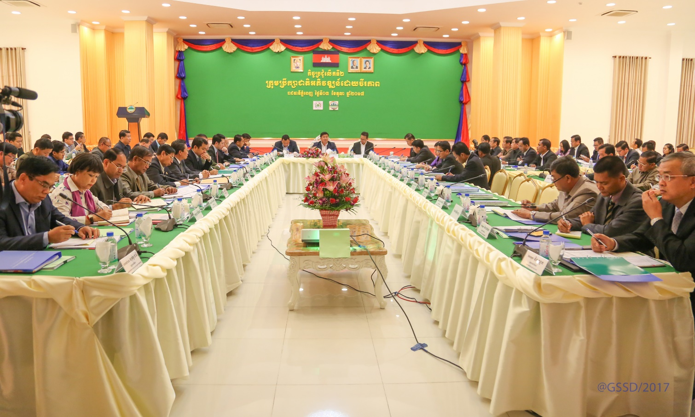
Photo 1: Second NCSD meeting chaired by H.E Say Samal, Minister of Environment and Chair of NCSD

CCCA support has extended to the establishment and operationalization of NCSD’s Climate Change Technical Working Group (CC-TWG). CCTWG was officially established on May 05, 2017 by Prakas of the Minister of Environment and Chair of the National Council for Sustainable Development (NCSD). This legal instrument designates H.E Chuop Paris, Deputy Secretary General, GSSD/NCSD, as chair of CCTWG, the Director of the Department of Climate Change (DCC) as first vice-chair, the Director of the Department of Marine and Coastal Zone Conservation, MoE, as second vice-chair, and representatives from 19 ministries/agencies in a total of 25 members. The mandate of CCTWG includes: mainstreaming climate change into national, sub-national or sectoral legislation and regulations; reviewing and strengthening of climate change monitoring and evaluation frameworks; contributing inputs to national and international reporting on the implementation of the national climate change response, including implementation of Cambodia’s Climate Change Strategic Plan (CCCSP) and sectoral climate change strategic and action plans (CCAP), and greenhouse gas (GHG) inventory; resource mobilization for an effective response to climate change through regular policy dialogues and coordination with donors, private sector and civil society organisations; identifying technology development and transfer needs and opportunities, and piloting of new technologies.

The first CCTWG meeting addressed M&E matters under the mandate of the group and focused on reviewing progress made in building institutional capacity to respond to climate change against the 2014 baseline, producing an update for the 5 institutional readiness indicators of the National Monitoring and Evaluation Framework for Climate Change Response. CCTTWG members also discussed the proposal for Cambodia’s Sustainable Development Goal 13 (SDG 13) on combating climate change prepared by DCC with the support of CCCA, and the proposed reporting mechanism to track progress of the implementation of climate change action plans (CCAPs) with guidance provided to 14 sectors on the upcoming reporting exercise. A second CCTWG meeting was held as part of the coordination mechanism with development partners (see details in the next section, Result 2).

Throughout 2017 CCCA has continued to provide support to the formulation and revision of a number of legal instruments related to climate change. This included substantial support to the later drafts of the Environmental and Natural Resources Code, in particular its Title on Climate Change, as well as comments of other relevant sections of the Code to ensure that a sound legal framework is set for climate change. In September 2017, after a last round of consultations, CCCA has integrated a MoE/GSSD internal review panel, to conduct a final review of the document. The Code is in its final stages of review with approval scheduled for 2018. CCCA has also incorporated GSSD’s inputs into the draft regulation on rules and procedures for carbon offset mechanisms. It is expected that these regulations will be submitted for approval early 2018.

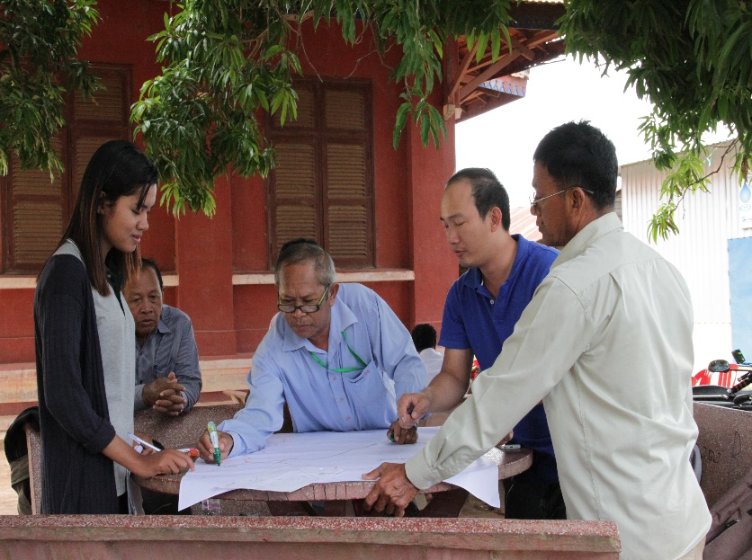
At the sub-national level, CCCA has expanded its support to three additional provinces, providing training to Provincial Departments of Environment (PDoE) in Koh Kong, Svay Rieng and Siem Reap provinces and to 12 commune councils on mainstreaming climate change into commune investment plans (CIP). Although slight delays were registered in May and June, due to national commune elections and campaign activities, the targeted 12 communes could successfully address climate change in the respective planning and budgeting instruments. In 2017, a greater focus of CCCA support to PDoEs and Commune Councils targeted the use of Vulnerability Reduction Assessment (VRA) tools recommended in the MoP-MoI guidelines for the preparation of CDP/CIP, assisting 12 communes in those three provinces in identifying vulnerabilities and impacts of climate change, defining adaptation actions that can strengthen their resilience, and including these actions in the respective CIP proposals. A summary of the results of the VRA conducted are presented in Table 1, documenting women’s participation in these discussions, with some communes showing gender parity (e.g. Chroy Svay and Tatay Kroum).
Photo 2: CC mainstreaming into commune development plan exercise at Siem Reap Province

Table 1: Selected communes
Province | District | Commune | Participants in VRA exercise  (Total/Women) | CC major impact
Svay Rieng | Svay Chrum | Basak | 15/3 women | Drought, insects epidemics, flood,  water shortage
Svay Rieng | Svay Chrum | Kampong Chamlang | 7/0 women | Drought, water shortage, flood
Svay Rieng | Svay Rieng | Svay Toea | 9/2 women | Flash flood, thunderstorm
Svay Rieng | Svay Rieng | Sangkhoar | 10/3 women | Flash flood, thunderstorm, drought
Siem Reap | Kralanh | Sambuor | 18/4 Women | Drought, flood  storm
Siem Reap | Kralanh | Snuol | 15/2 women | Drought, disease, flood
Siem Reap | Srei Snam | Prei | 13/5 | Drought, Flood
Siem Reap | Srei Snam | Slaeng Spean | 10/4 | Drought, thunderstorm, flood
Koh Kong | Koh Kong | Trapang Rung | 22/12 Women | Sea Level rise, flood, disease
Koh Kong | Koh Kong | Tatai Kraom | 18/6 Women | Sea Level rise, flood, disease, drought
Koh Kong | Sre Ambel | Kampeng | 15/4 Women | Sea Level rise, flood, disease, drought
Koh Kong | Sre Ambel | Chroy Svay | 12/6 Women | Sea Level rise,  flood, disease  drought

Based on VRA exercises conducted, these communes developed a portfolio of climate change project ideas to include in their proposals for the 2018 CIP to be discussed at District Investment Workshops. Table 2 below indicates the proportion of climate change projects in each CIP and provides examples of climate change projects proposed by these communes.

Table 2: Climate Change projects presented in 12 CIPs
Province | District | Commune | Number of CIP projects | # of CC Projects | Example of Project
Siem Reap | Kralanh | Sambuor | 34 | 9 | Construct water gate
Siem Reap | Kralanh | Snuol | 37 | 9 | Collect data and monitor the living conditions of vulnerable households
Siem Reap | Srei Snam | Prei | 42 | 10 | Training on livestock raising that adapt to changing climate
Siem Reap | Srei Snam | Slaeng Spean | 47 | 10 | Promote the use of resilient rice varieties
Svay Rieng | Svay Chrum | Basak | 23 | 12 | Construct ponds to store water
Svay Rieng | Svay Chrum | Kampong Chamlang | 21 | 11 | Install sewer to drain wastewater and to discharge heavy rainwater
Svay Rieng | Svay Rieng | Svay Toea | 20 | 10 | Campaign on clean city
Svay Rieng | Svay Rieng | Sangkhoar | 20 | 12 | Rehabilitate canals to combat droughts
Koh Kong | Koh Kong | Trapang Rung | 25 | 5 | Construct a landfill to manage solid waste
Koh Kong | Koh Kong | Tatai Kraom | 31 | 6 | Public awareness raising on climate change
Koh Kong | Srey Ambel | Dorng Peng | 25 | 8 | Repair water gates to protect sea intrusion
Koh Kong | Srey Ambel | Chroy Svay | 34 | 8 | Construct seawater dike

Following the approach adopted in the previous year, and the successful CC mainstreaming work conducted in 2016 in Oddar Meanchey, Takeo and Tbong Khmom, CCCA has also provided technical and financial support to three selected communes to implement adaptation projects they had identified and included the respective 2017 CIPs.

Table 3: List of CIP supported by CCCA
Province | District | Commune | CIP propose project | Direct Beneficiaries | Costing (USD)
Tbong Khmum | Ou Rang Ov | Domril | Renovate gravel road (750 meter) | 1258/ 567 women | 4,978
Tbong Khmum | Ou Rang Ov | Domril | Eco School at Domril secondary school: Solar Pumping, School Gardening, Solar light | 247 /158 women | 8,000
Takeo | Prey Kabas | Bankam | CC awareness raising | 235/76 women | 500
Oddar Meanchey | Banteay Ampil | Kok Kpos | Water storage for Kok Kpos Primary School | 127/59 women | 3,800
Oddar Meanchey | Banteay Ampil | Kok Kpos | Water storage for Kok Kpos Secondary School | 256/139 women | 3,800
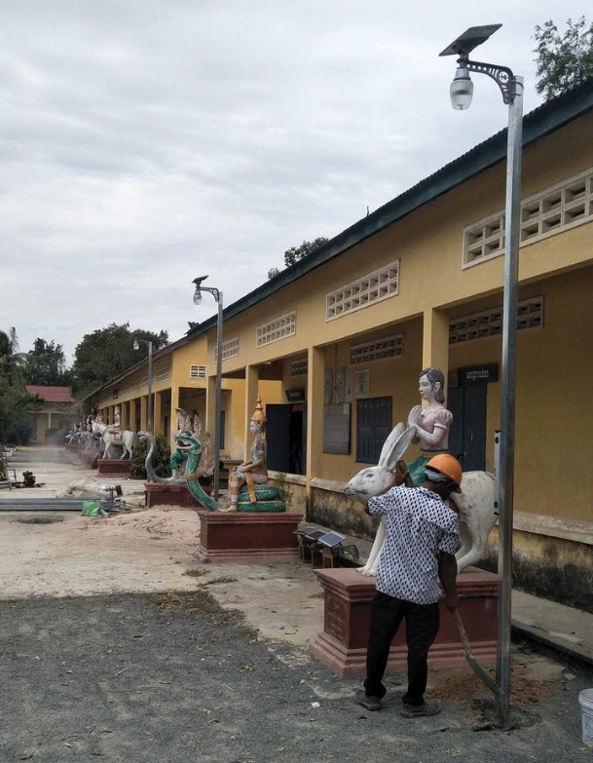
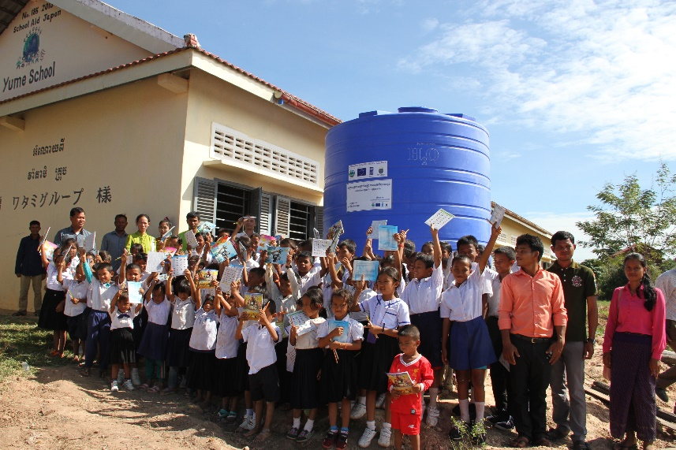

Photo 3: CCCA support CIP Project at Oddar Meanchey on Water storage

Photo 4: CCCA support CIP Project at Takeo on Solar light at school

Output 1.2: National and key sectoral M&E frameworks are developed and submitted for approval
A brief of the National M&E Framework for Climate Change Response was published in Khmer with the support of CCCA. The official document of the national M&E framework was prepared (in Khmer) and submitted to GSSD/NCSD for final review and approval. Signing is expected early 2018.

In order to track progress of Cambodia’s efforts in building national institutional capacity to respond effectively to climate change, NCSD/CCTWG conducted an update of the 5 institutional readiness indicators of the National CC M&E Framework in June 2017, with discussions of the score cards facilitated by CCCA. The results (Table 4 below) show an overall increase in all five institutional readiness indicators, with the coordination mechanisms, and development of climate policy, strategies and action plans for climate change response continuing to register the highest scores (respectively 61% and 50% in 2017), while the status of production, access and use of climate change information continued to score the lowest (26% in 2017). Also noted is the uneven rate of improvement of institutional capacity over the 5 dimensions of institutional readiness, with the indicator on CC financing for example increasing at a significantly higher pace than other readiness indicators.

Table 4: Institutional Readiness indicators in 2014 and 2017
Institutional Readiness indicators | 2014 Baseline | 2017  Update
Indicator 1: Status of development of national policies, strategies and action plans for climate change response | 30% | 50%
Indicator 2: Level of inclusion of climate change in long, medium (NSDP) and short term national (PIP) and subnational planning documents. | 22% | 37%
Indicator 3: Establishment and functionality of a national mechanism for coordination of climate change response and implementation of the CCCSP. | 45% | 61%
Indicator 4: Production, access and use of climate change information | 17% | 26%
Indicator 5: Availability and effectiveness of a financial framework for climate change response. | 23% | 42%

One should note that some of the milestones defined in the institutional readiness scorecards for these indicators constitute the focus of much of the work that national institutions are currently carrying out, e.g. 1) CCCSP progress monitoring reports, 2) regular meetings to review the progress of the CCCSP and the CCAP, 3) the establishment of an inter-ministerial sub-working group on climate finance, 5) a code to track climate relevant expenditure in NCDD-S / subnational, 6) formal procedures in place in MEF for screening major national budget investment against climate risk. Thus, not only a positive movement of these indicators is expected in the near future, but CCTWG discussions of the milestones while updating these 5 institutional capacity indicators are also expected to help focus work of the respective sectors and accelerate the achievement of greater levels of capacity in the coming years.

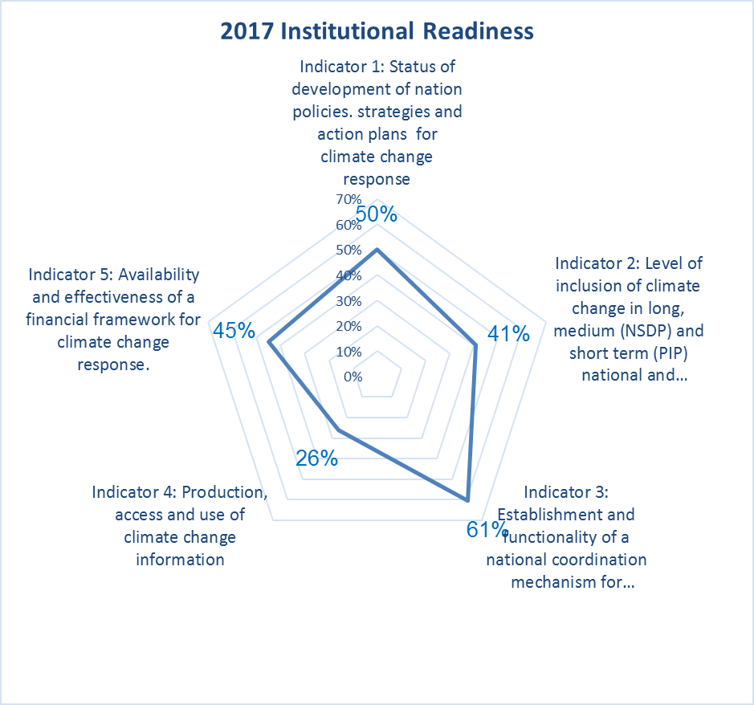

Figure 1: Update of Institutional Readiness Indicators in 2017

Preparatory work has been initiated on the automatization of the update and dissemination of the results of the M&E impact indicators of the national framework, in particular Vulnerability and Loss and Damage indicators. As a result of discussions with MoP, Secretary of State H.E. Hou Taing Eng agreed to grant access to CDB data for GSSD (designating MoP technical staff to liaise with CCCA/DCC and the respective consulting firm and granting immediate access to the data). Once the automatization process is tested, a data-sharing agreement already drafted is expected to be signed between the relevant institutions. HE underlined MoP’s willingness to cooperate with NCSD and the Secretariat on the production of relevant climate change indicators. CCCA will continue to work with a consulting firm in 2018 to ensure that this process is completed and that results of these indicators are accessible to all users through the CC Portal currently under development.
Ensuring alignment of M&E instruments relevant to climate change work has been a central part of CCCA ongoing technical support to DCC and sectors, including support to the development of localized SDGs and the CCCAP reporting mechanism. In addition to the in-depth work on C-SDG 13 - Combating Climate Change where indicators for 4 targets have been developed, CCCA has also provided support to the broader discussions to localize SDGs, focusing on environment and sustainable development targets and indicators being drafted by GSSD. Support included the facilitation of a consultation workshop held in Siem Reap to finalize draft proposals for 12 Goals, 36 Targets and 69 indicators, including SDG 13. A final proposal has been submitted to MoP in October 2017.

The instrument for reporting on CCAP implementation has been presented by CCCA at the first CCTWG meeting in June. Fourteen sectors with approved CCAPs were formally requested to assess and report on their sectors’ efforts in implementing the respective CC response action plans. The assessment covers five dimensions, namely management arrangements, implementation status, achievements and impacts, current capacity cap, and way forward to accelerate CCAP implementation; CCCA is providing technical support to CCTWG members and relevant sectoral staff for this exercise. The assessment of CCAP implementation will feed into the CCCSP mid-term review to be conducted in 2018. Recruitment of international and local consultants to assist in the CCAP reporting and MTR will take place in early 2018.

MoP has also discussed with DCC/CCCA support for development of the new cycle of NSDP. A work program has been prepared identifying where support from CCCA is needed, including support to the development of guidance and training to sectors on climate change mainstreaming in NSDP. MoP has suffered delays but the work is expected to start early 2018.

Output 1.3: Capacity of key line ministries has been strengthened to manage their CCAP and contribute to CCTWG/ NCSD activities

The CC related capacity assessment of NCSD, GSSD, and CCTWG/sector CC teams is to be conducted in conjunction with the broader capacity assessment of NCSD (under the Environmental Governance Project). CCCA has provided inputs for the TORs of the staff to be recruited under the EGR project as well as to the project’s workplan (including the scheduling of the capacity assessment/s and the formulation of the capacity development plan/s). The capacity assessment has started at the end of 2017 and will be finalized in early 2018. While this joint assessment focuses on GSSD/NCSD capacity gaps, including human resources, capacity needs of most sectors represented in the CCTWG will be assessed during the reporting exercise on CCAP implementation.
While the capacity assessments and capacity development plans are being prepared, CCCA has continued to provide support to 12 government staff from NCSD, CCTWG, GSSD and DCC to attend international climate change events such as COP 23 and SBSTA meetings as well as other trainings.

Figure 2: Participants in international meetings and training

To date, 14 line-ministries and agencies have received support from the CCCA Grant Facility for the implementation of priority actions targeted in their respective Climate Change Action Plan. Progress made by the grantees is presented below. Table 5 provides a brief update on the core output and outcome targets of CCCA grants for Window I, rounds 1 and 2. Table 6 provides a more detail account of the implementation of these grants at the end of 2017.

Table 5: List of Grantee in window I round 1 and round 2
# | Applicant | Project Title | Key Partners | Project Duration | Budget (US$) | Target Areas
1 | Ministry of Health- Preventive Medicine Department (PMD); National Centre for Parasitology, Entomology and Malaria Control (CNM) | Strengthening country capacity to deal effectively with climate sensitive vector-borne and water-related diseases and reducing the health impacts of disasters | World Health Organization (WHO) | 01 September 2015-28 February 2018 | 400,000 | PMD: Kandal, Siem Reap, Banteay Meanchey, Mondulkiri, Rattanakiri,  Battambang, Kampong Thorn, Kampong Cham, Tbong Kmom, Kratie, Pursat, Stung Treng, Takeo, Prey Veng, Koh Kong, Prah Vihea, Sihanouk, Kampot, Kampong Speu and Phnom Penh;  CNM: Preah Vihea, Koh Kong, Rattanakiri, Mondulkiri, Siem Reap,  Banteay Meanchey, Tbong Kmom and Kandal
2 | Ministry of Public Works and Transport (MPWT), Department of  Planning (DoP) | GHG Emissions Inventory and Mitigation Plan for the Road Transport Sector in Cambodia | Siem Reap Provincial, Municipal and City  Clean Air Asia | 01 September 2015-28 February 2018 | 250,000 | Siem Reap City
3 | Ministry of Water Resources and Meteorology (MOWRAM) | Increasing the knowledge of the water cycle in order to reduce vulnerability to Climate Change hazards through an integrated approach | Cambodian Red Cross (CRC)  Institute of Technology of Cambodia (lTC), Department of Rural Engineering (GRU) | 01 September 2015- 31 August 2018 | 350,000 | Oddar Meanchey Province
4 | National Committee for Disaster Management (NCDM) | Living with Disaster Risk and Climate Change Impact in Coastal Area | PCDMs, PDoRD, NCDD, Dol, DoWRM | 01 September 2015- 31 August 2017 | 100,000 | Kampot and Kep Province
5 | Ministry of Rural Development (MRD) | Climate-Proof Integrated Rural Community Development in Kampong Thorn Province | Caritas Cambodia | 01 September 2015-28 February 2018 | 250,000 | Kampong Thom Province
6 | Ministry of Women's Affairs (MoWA) | Mainstreaming of gender impacts of climate change and disasters in education sector | Ministry of Education, Youth and Sports (MoEYS) | 01 October 2015-30 September 2017 | 100,000 | Kampong Chhnang, Kampot, Stung Treng and Svay Rieng Province
7 | Ministry of Education, Youth and Sports (MoEYS), Department of Curriculum Development (DCD) | Mainstreaming Climate Change in Education (MCCE) | Mlup Baitong Organization  Ministry of Women's Affairs (MoWA) | 01 October 2015-30 September 2018 | 350,000 | Kampong Chhnang, Kampot, Stung Treng and Svay Rieng Province
8 | Ministry of Agriculture, Forestry and Fisheries (MAFF) | Increasing Resilience to Climate Change for farmers in rural Cambodia: through Climate-Smart Agriculture practices | Group for the Environment, Renewable Energy and Solidarity (GERES)  Climate Change, Agriculture and Food Security (CCAFS)/ Environmental Changes Institute (ECI) of the University of OXFORD | 01 December 2015-30 November 2018 | 450,000 | Kandal, Kampong Cham, and Kampong Chhnang Province
9 | Ministry of Industry and Handicraft (MIH) | Demonstration of best practices on available technology for contribution to climate change adaptation and mitigation in industrial and handicraft sectors | UNIDO | 01 April 2017-31 March 2019 | 250,000 | Phnom Penh, Battambang, Kampong Speu, and Kandal Province
10 | Ministry of Mines and Energy (MME) | Promote Low-Carbon Technologies in Energy Sector | N/A | 01 January 2017-31 December 2018 | 250,000 | Pursat and Kampong Thom Province
11 | Ministry of Tourism (MoT) | Public Awareness of Climate Change in Tourism Sector | N/A | 01 January 2017-31 December 2018 | 125,000 | Phnom Penh, Siem Reap, Battambang, Sihanoukville, and Koh Kong Province
12 | Ministry of Land Management, Urban Planning and Construction (MLMUPC) | Promote settlement development adapted to natural disasters | Habitat for Humanity Cambodia (HFHC) | 01 April 2017-31 March 2019 | 250,000 | Preah Sihanouk, Tbong Khmum, and Kratie Province
13 | Ministry of Information (MoINFO) | Strengthening and Capacity Building on Climate Change through Television, Radio, and Digital Media | N/A | 01 January 2017-31 December 2018 | 125,000 | National level
14 | Ministry of Environment (MoE) | Develop and test low carbon resilient approaches and options in urban areas | N/A | 01 April 2017-31 March 2019 | 300,000 | Phnom Penh

Support to CCAP implementation through projects funded by the CCCA Grant Facility Window 1 (rounds 1 and 2)
Table 6: Status of CCCA grants
 | Ministry | Project Name | Key achievements to date | Challenges
1. | Ministry of Health- Preventive Medicine Department (PMD); National Centre for Parasitology, Entomology and Malaria Control (CNM) | Strengthening country capacity to deal effectively with climate-sensitive vector-borne and water-related diseases and reducing the health impacts of disasters | - Two workshops on development of common operational datasets for health sector inputs into DRR/DRM and CamDi. As a result, an official letter (including Annex of Term of Reference) from MOH minister to NCDM management was drafted to endorse cooperation on data-sharing.  - First, second and third round of entomological survey (vector borne diseases) were conducted;  - Three workshops and one consultative meeting to align the National Climate Change Action Plan for Public Health (NCCAPPH) with National Strategic Plan on Disaster Risk Management for Health (NSPDRM). As a result, a final draft new strategy and action plans in English and Khmer version are developed;  - Mid-term review of the project conducted;  - Second workshop on development of case definitions and clinical guidelines for emerging climate-sensitive infectious diseases (leptospirosis, melioidosis and schistosomiasis). As a result, the Clinical Guideline for these diseases and action plan have been finalized;  - Seven training workshops to scale-up education and training of health professionals in: prevention, diagnosis and management of water-related diseases (WRDs), applied epidemiological analysis, and application of GIS for health. This led to improvements in key stakeholders’ skills in environmental epidemiology and its application for the management of climate-sensitive diseases;  - Third training workshops on health sectors role in Disaster Risk Reduction (DRR) with a total of 58 participants (10 of them are female);  - The PCR and ELISA machines for dengue surveillance have been received. Four technical staff from National Dengue Control Program/CNM are under training so that dengue samples can be analyzed directly in CNM instead of Institut Pasteur (IPC);  - The National Dengue Control Program (NDCP), National Center for Parasitology, Entomology and Malaria Control/CNM, already received the historical data from Ministry of Water Resources and Meteorology (MOWRAM) for 2016 and 2017 such as Temperature, T-Min, T-Max, Humidity, and Rainfall. CNM now starts analysing the data in conjunction with dengue data and the findings will be shared during a consultative meeting in 2018. | No major challenge. For 2018, analysis of climate data and how it can be used for early warning on dengue will be a key focus area, as well operationalization of data-sharing between MOH and NCDM.
2. | Ministry of Water Resources and Meteorology (MOWRAM) | Increase the Knowledge of the water cycle in order to reduce vulnerability to Climate Change hazards through an integrated approach (IKWCRCC) in 3 districts of Oddar Meanchey province | - Project site assessments on the monitoring network locations for the weather and surface water monitoring. As a result, the location for meteorological station is at Chong Kal commune, and the locations for hydrological stations are at Deng, Chong Kal, and Lum Toung communes, Oddar Meanchey province;  - The PDOWRAM project team has compiled and collected water cycle data every month as planned;  - One meteorological station, 6 ground water monitoring wells, 3 drilling wells (observation wells) and 2 river gauges and 6 rain gauges were installed in order to record climate data and extend the scope of current monitoring;  - A baseline survey report has been completed;  - Agreement on exchange of water cycle data collected by the Department of River Works and Hydrology and the Department of Meteorology. This data is now gathered in one unique database able to assess the situation on water resources in Oddar Meanchey;  - A study on design of canal rehabilitation (4 kilometres long and 1,5 meter-deep) benefiting a total of 1142 households was completed. As a result, around 4 km of canal have been rehabilitated and the community completed the green grass plantation along canals in order to avoid erosion and maintain sustainable use. Moreover, the farmer water user groups have been established and are in process to get official accreditation from MOWRAM.  - A training on TST (Total Station) equipment in order to get land elevation and location data. and data processing was provided for PDOWRAM staff;  - Training on land management/GIS software for 9 MOWRAM staff;  - Training on how to use Topo station machine (which is helpful to monitor the condition of groundwater table against the rainfall pattern and ground water extraction the area as well as availability of ground water, and this machine is used to design and manage the structured surface water, and it helps the decision maker to with source should be used for what purpose based on their availability), analyse data from the tools, development of database system, compilation of data and reviews and data interpretation for 9 MOWRAM staff;  - Download data from 6 rain gauges, 6 ground water monitoring wells, 2 river gauges and 1 weather station on a monthly basis and monitoring existing equipment;  - Three pumping tests were conducted in order to test the operation of the pumping and monitoring equipment, to make sure that everything is working safely and efficiently, and if applicable, to confirm that the contractors have done their job properly and to provide information on water quality;  - Hydrological data of river water levels and weather data have been collected on a monthly basis to share with a project partner, namely ITC for processing and analysing;  - 4 ITC bachelor students have been supported and successfully completed their research thesis on 1) Study of groundwater by pumping test and DRASTIC method for making vulnerability mapping in Oddar Meanchey province; 2) Application of PRMS model to simulate stream flow of Otameng Catchment; 3) Determination of Portable Water Supply Network in Chong Kal, Oddar Meanchey and 4) Study on water supply system in Anlong Veng district at Oddar Mean Chey province;  - Farmer Water Users Committee/Group at Chong Kal was officially accredited by the Governor of Oddor Meanchey province. Now, it is under process to submit the MOWRAM.  - The preliminary findings from water cycle monitoring in Oddar Meanchey were presented to the key stakeholders during CCCA learning event. | - No major issues
3 | Ministry of Public Works and Transport (MPWT), Department of  Planning (DoP) | Green House Gas Emissions Inventory and Mitigation Plan for the Road Transport Sector in Cambodia | - Final draft Guidance Document and spreadsheet for national GHG Inventory for Road transport sector has been completed, including inputs from GSSD/DCC;  - Training on national greenhouse gas inventory for Road Transport held at the Royal University of Phnom Penh for MPWT staff;  - Final Guidance Document for city-level GHG Inventory for Road Transport sector developed;  - Final draft technical report on national GHG inventory for the road transport in Cambodia has been submitted for approval;  - Dissemination workshop on EI results was organised;  - EI training workshop at city level was conducted;  - A Stakeholders Engagement Workshop was organised to review the modules on city-level GHGs inventory;  - Conducting of Rapid GHG EI for road transport in Siem Reap with 25 participants (5 of whom are female). As a result, a report of rapid GHG EI for road transport in Siem Reap is drafted;  - All technical documents including guidance document and spreadsheet, guidance documents for city-level GHG inventory are in process to get an endorsement from MPWT management;  - MPWT pilot mitigation demonstrations in Siem Reap have been under process for consultation and discussion. These ones are expected to be conducted from early 2018; | - Difficulty in accessing national fuel consumption data: in the end the team obtained customs data (imports of fuel) and monitoring data from MME  - Pilot mitigation activities in Siem Reap are behind schedule
4. | Ministry of Rural Development (MRD) | Climate-Proof Integrated Rural Community Development in  Kampong Thom Province | - Field survey on needs and capacity assessment (including site assessment);  - Finalized vulnerability mapping and technical guidelines for climate resilient rural infrastructures (water);  - Published 500 books of training manual on “Training of Trainer on Food Security and Nutrition” in context of climate change;  - 8 model green houses were established and there are 02 water gates that were constructed (with co-financing);  - 2 meetings with PCDM of Kampong Thom to produce contingency planning book;  - Development of housing guidelines for climate resilience in Cambodia is in progress;  - 4 meetings were conducted at village level to develop DRR Plan by using Hazards Vulnerability Capacity Assessment (HVCA) tools, and one meeting with commune council’s members and village leaders in order to discuss about the integration of DDR/CCA in to commune development plan;  - 6 trainings on climate change concept and resilience were provided to members of village development associations (VDA) and members of NCDM at village and commune level in the target district;  - 15 families have received support to renew their houses while 45 received a new model resilient house;  - A consultative workshop on vulnerability mapping was organised with 46 participants (8 of whom are female);  - Eight awareness raising events on climate change and sanitation and hygiene were conducted with 969 community members.  - An underground water study was conducted;  - A study visit on hydroponic home garden was conducted to briefly explain the selected farmers and local authorities about construction of hydroponic home gardening, materials needed, and process of vegetable growing. As a result, all farmers selected are interested in the hydroponic home garden;  - Project completed construction of 4 flood proofed latrines, one rain water collector, 7 pump-wells, 3 combined wells and 4 adaptive home gardens. As a result, a total of 288 vulnerable households are benefiting directly from these climate proofed infrastructures. | - Quality assurance of products such as vulnerability mapping and guidelines, was time-consuming.  - It is hard to find a contractor for small and scattered construction such as latrines;  - Some activities including resilient infrastructures were delayed due to heavy rain in target areas in 2017.
5 | National Committee for Disaster Management (NCDM) | Living with Disaster Risk Reduction and Climate Change Impact in Coastal Areas | - Developed training plan and curriculums focusing on the priority area of Emergency Preparedness and Response, in cooperation with PCDM;  - Women climatic platform members selected. 25 hygiene change agents selected and trained participated in distribution of safe water;  - Two water stations are completely constructed and fully functioning. Since then, 20 people have been trained on how to produce pure drinking water, marketing and maintenance of the Water System Unit. Five primary schools with 1178 students and 18 poor families receive free drinking water;  - A training on business concept for 19 people;  - 6 awareness raising events on water and sanitation to communities with a total of 77 participants (65 of whom are women);  - Training on how to integrate DRR/CC activities into CIP for target commune councils;  - Facilitated the meeting with Commune-CCDM for developing Emergency Preparedness Response Plan (EPRP: tools, process, district integration workshop);  - NCDM lead to organize the meeting with PCDM, DCDM, CCDM to review roles and responsibilities of all groups involved in provincial EPRP;  - NCDM conducted training to provincial and local government staff on Early Warning System, damage reporting;  - 7 climatic ponds for 7 vulnerable households in Kep province and 4 vulnerable households in Kampot province were established.  - Meeting with CCDM was organized to develop Emergency Preparedness and Response Plan. As a result, EPRP in Kampot was finalized and EPRP in Kep is drafted;  - 8 awareness raising events on DRR and CCA were conducted with a participation of 309 villagers (187 female);  - 8 awareness raising events on hygiene promotion were organised for 372 villagers (247 female);  - Coordination meetings with key people at village level to integrate climate change response into Commune Investment Plan. The activities prioritized by communes are 1) need more support from commune fund for digging family ponds and 2) small irrigation system (village canal), which will be brought up to a district integration workshop to find support from line departments. | - N/A. The project is operationally completed. Cost-benefit and sustainability analysis of the water station community business model is ongoing.
6. | Ministry of Agriculture, Forestry and Fisheries (MAFF) | Increasing Resilience to Climate Change for farmers in rural Cambodia: through Climate Smart Agriculture practices | - Inception workshops in the three target provinces conducted;  - Participatory Vulnerability Assessment tool completed (includes scenarios/models, and role play);  - Manual on climate-smart agriculture practices and guidelines on climate vulnerability and assessment of adaptation strategies to climate change using participatory modelling and simulation have been finalized;  - 4 trainings on climate-smart agriculture practices, diagnosis and implementation held for MAFF national and provincial staff;  - 4 trainings on diagnosis of climate vulnerability and assessment of adaptation strategies to climate change using participatory tool and modelling held for MAFF national and provincial staff;  - Vulnerability assessment diagnostics conducted in all three target provinces/communes;  - 7 RUA intern students have been selected to be involved and learn from the project;  - Project developed CSA demonstration options report for each commune resulting from vulnerability assessment;  - In collaboration with project partner, project conducted completed the Orientations for three targeted Provincial Agriculture, Forestry, and Fisheries (PDAFF) on Demonstration Actions.  - Project is under process for selection of household beneficiaries, training and installation of demonstration activities. As a result, 61 households are identified and selected for demonstration activities. | - No major issues
7. | Ministry of Women's Affairs (MoWA) | Mainstreaming of gender impacts of climate change and disasters in education sector | - Joined the vulnerability assessment of eco-schools conducted by the MOEYS project, to provide support on gender;  - Conducted monthly coordination meeting with MOEYS/DCD and relevant stakeholders to finalize training curriculum/modules. As a result, gender is included into the draft climate change training curriculum (Grade 10-12)  - Organized two meetings to develop the gender-sensitive training curriculum on CCA/DRR for grades 7-9;  - ToT training curriculum including modules (grade 7-9) was finalized;  - A consultative workshop on Emergency Preparedness Response Plan Development at school and community level was organized;  - VRA and activities plan of eco-school was conducted at Hun Sen Angkor Chey and Kampong Tralach high school;  - Training of Trainers were conducted in four targeted provinces with 97 participants (40 of whom are female);  - A training on life skills and alternative agriculture skills was organized with 183 participants (144 women);  - The school kits and drawing materials were provided to 60 most vulnerable female students in target schools for drawing contest preparation. A drawing contest was organised;  - GCC conversation/dialogue were organized to discuss about women’s needs when disasters or climate change happened with 80 participants.  - Project organized a training on Gender Climate Change for 27 MoWA and DCD officials (17 of whom are female) to understand more about mainstreaming gender impact into climate change adaptation on four prioritized sector, such as agriculture, health, water resource and public transport;  - Project established School Disaster Management Committee in each target school for strengthening and raising awareness of school disaster preparedness;  - Project provided chicken and some tools to 60 most vulnerable head-household through climate-smart agriculture techniques.  - Project provided seeds and tools to schools for students to practice resilient agricultural gardens through promoting climate-smart agriculture in 4 target schools;  - Project constructed one solar pump connected with water container, 2 water containers, one concrete water containers for rainy water collection, 10 water filters, 18 fans, a lightening protector, and 3 thermometers in response to the schools climate change response needs;  - Project provided First Aids Kits to 4 target schools;  - Drawing contest award in Phnom Penh with a total of 82 participants including students and teachers (30 are women). | - Project is operationally closed.
8. | Ministry of Education, Youth and Sports (MoEYS), Department of Curriculum Development (DCD) | Mainstreaming Climate Change in Education (MCCE) | - Organized two-day workshop on mainstreaming CC into education sector with the members of technical working group;  - The project conducted project launching in four target provinces with participation of approximately 50 educational officers and teachers and 100 students for each target province;  - Two training workshops on project development and management were provided to project staff at two target provinces to enhance their capacity to effectively implement the project;  - The project organized a one and half-day workshop to discuss the establishment and management of each of the 10 pilot Eco-Schools. In doing this, firstly a VRA (Vulnerability Reduction Assessment) to CC was conducted for each Eco-School and its catchment area. Then issues to be addressed for each Eco-School were identified, prioritized, and selected;  - Organized three TWG meetings on Modules Development of Mainstreaming of Climate Change in Education. As a result, second draft of training curriculum on climate change (grade 10-12) was developed;  - The VRA and operational plans and budget of eco-schools have been finalized and a training on implementation of eco-schools was carried out in each target school;  - 30 teachers (6 of them are female) are selected to test a new climate change curriculum (grades 10-12);  - 10 formal agreements on MCCE Project Implementation were signed between Department of Curriculum Development (DCD) and each school;  - Eco-School Steering Committee and Eco-Club Committee of each school were established. As a result, plans of Eco-Club are prepared.  - A Facebook Group named “Eco-School Alliance” was created for all schools to share knowledge, experience and project progress: https://www.facebook.com/groups/1138629222932365/  - A 3rd Cambodian Eco-School Prize was awarded to one of MCCE Project’s target schools – Hun Sen Chrey Thom High School;  - A technical training on composting and vegetable gardening was delivered;  - A technical training on how to grow trees, set-up sample forest demonstration and establish biodiversity garden was delivered by Global Forest and Biodiversity Innovative (GFB);  - 10 Information boards, 8 water containers, 10 irrigation systems, 27 garbage bins, 33 garbage cages, 2 school ponds, latrines constructed and renovated linked with11 hand washing sinks, two pumping wells, 1176 trees plantation, 5 school gardens, 16 ceiling fans, construction of a water release system, and demonstration sites of compost making;  - 1,800 T-shirts and 1,800 packages of study materials (composed of notebooks, pens and rulers) have been produced and distributed;  - A final draft Climate Change Syllabus (grade 10, 11 and 12) has been tested, including training of trainers, and is expected to be launched after completion of the trial period in early 2018; | - Partnership issue with Mlup Baitong has been resolved and a new agreement has been signed and implemented, giving a more prominent role to MOEYS.
9 | Ministry of Industry and Handicraft (MIH) | Demonstration of best practices on available technology for contribution to climate change adaptation and mitigation in industrial and handicraft sectors | - Project steering committee (including UNIDO as member) was formed and approved by the MIH Minister.  - The rules and procedures and methodology for GHG inventory in industry are in progress;  - The technical guidelines for GHG emission reduction and RECP and EMS are in progress;  - The training manual on national GHG inventor in IPPU sector is in progress. | - Some activities were delayed at the start-up phase in 2017, the project is now making progress.
10 | Ministry of Mines and Energy (MME) | Promote Low-Carbon Technologies in Energy Sector | - A kick-off meeting was organized with 29 participants (5 are female);  - A team is formed to facilitate the data collection, analysis and compilation for the energy balance report with detailed SOP and worksheet in both English and Khmer;  - The technical committee for energy statistics is established and awaiting approval from minister;  - An energy statistic manual is drafted;  - A field monitoring visit was conducted to the pilot renewable energy sites in Pursat and Prey Veng province in order to understand the need, change from earlier survey, project update to the beneficiaries, site energy demand study and to establish the connection;  - A training course was held on Energy Balance and Statistics Development with 42 participants (4 of them are female);  - The energy balance study is in progress;  - An international expert has been recruited to support the work on low carbon technology assessment in Cambodia;  - A site assessment has been done to study the new potential pilot site in Kampong Thom Province, the energy demand and potential of low carbon technology. As a result, Kampong Thom is selected for the pilot activities.  - A study on low carbon technology for electricity generation is in progress;  - A training workshop on analytical tools for assessment of technologies was organized with 35 participants (3 of them are women). | No major issues
11 | Ministry of Tourism (MoT) | Public Awareness of Climate Change in Tourism Sector | - Project organized a domestic study tour to another successful Community-Based Ecotourism development in Kampot;  - Project conducted a rehearsal workshop on Cambodia CBT/CBET Standard;  - Project organized a public workshop on green hotel standard in Phnom Penh;  - Project installed 6 billboards and 150 rubbish bins in Phnom Penh in support of clean city before Water Festival;  - Project produced draft leaflet for Peam Krasoap CBET; | No major issues
12 | Ministry of Land Management, Urban Planning and Construction (MLMUPC) | Promote settlement development adapted to natural disasters | - An inception workshop was organized;  - Terrain study was conducted in three target provinces;  - Two consultants were recruited to design resilient housing models and technical guidelines;  - Project staff also conducted site assessment to the houses affected by storm and houses affected by flood in 3 target provinces. | No major issues
13 | Ministry of Information (MoINFO) | Strengthening and Capacity Building on Climate Change through Television, Radio, and Digital Media | - Project created Facebook page (link: https://www.facebook.com/ mediaforclimatechangecambodia/) and Twitter page (link: https://​twitter.​com​/MOInfoclimate);  - A concept note of Radio/TV Talk-Show was developed;  - Project developed 3 Radio/TV talk show with a participation of Secretary General of NCSD, deputy director of DCC and representative of UNDP. It broadcasted on National Television of Cambodia and on Radio National Kampuchea via FM 105.75 and AM 918.  - Project created and updated information on social media including facebook page and youtube (link: https://www.youtube.com/watch?v=​hZlaF5CfEZE). A video of the Talk Shows and features was also published on the official Facebook page and YouTube as well;  - Project also developed one video spot on climate and water data collection experience in Oddar Meanchey;  - First draft of concept note of media training was developed in consultation with CCCA/DCC staff. | - N/A
14 | Ministry of Environment (MoE) | Develop and test low carbon resilient approaches and options in urban areas | - Project is under process to conduct school selection, baseline and vulnerability assessment.  - Project is under process to procure e-bikes.  - Project is under process to procure for production IEC/BCC materials. | This project is behind schedule.

Table 7: Status of core indicators and targets of CCCA grants for Window 1 Round 1 & Round 2
Targets (output indicators only)* | December 2017 status
- At least 18 different types of adaptation activities and 5 different types of mitigation activities will be demonstrated, with 8,000 households as direct beneficiaries (at least 10% female-headed households and 10% ID poor households);  - At least 1,000,000 USD in public and private resources will be leveraged by CCCA grant projects for adaptation and mitigation activities;  - 400 provincial, national and local government staff will be trained on CC adaptation and/or mitigation (at least 20% female);  - 9,000 community members will be trained on CC adaptation and/or mitigation (at least 40% female);  - 30 knowledge products will be published (including e.g. flood vulnerability maps, guidelines for CC resilient infrastructures, CC curriculum for schools, etc.);  - At least 12 Government policies or regulations will take into account evidence produced by CCCA projects | - 23 adaptation activities are operational (surveillance and treatment of climate sensitive diseases, drinking water and sanitation pilot, climate-resilient access to water, meteorology station, canal rehabilitation, latrines, wells, home gardens, first aid kids, school kids, lightning protector, thermometers, solar pump, fans, water containers, information board, school irrigation systems, ponds, trees plantation, compost making, water releasing system, garbage bins and garbage cages), with 16,024 households as direct beneficiaries (including 2.8% female-headed and 7.8% ID poor households);  - 1,493,067 USD have been leveraged to date;  - 718 government staff trained (25.9% female);  - 2879 community members trained (61.2% female);  - 20. In addition to the policy/regulatory documents mentioned below (9), an additional 11 knowledge products have been published, including e.g. database including 2 years of chronic water cycle data in addition to historical data for Oddar Meanchey, technical guidelines on resilient housing and 2 architectural designs on resilient housing, 3 Radio/TV talk shows and 1 documentary feature on CC, climate vulnerability map for one district of Kompong Thom, report on GHG emissions from transport in Siem Reap.  - 9 policy or regulatory documents to date including three clinical guidelines for climate sensitive diseases, guidelines and report on GHG emissions in the transport sector, Training Curriculum on Climate Change (Grade 10-12), technical guidelines on climate-proof rural water infrastructures, guidelines on participatory methodology for diagnosis on climate vulnerability and assessment of adaptation strategies for MAFF, energy balance sheet manual, green hotel standards.

Spot checks were conducted once a year as scheduled in 2017 to all (22 grantees) with a few grantees visited twice a year such as MOWA, NCDM and MOWRAM. Spot checks aim to provide an opportunity and give these ministries, agencies and NGOs hands-on support and guidance on financial and administrative procedures.
Table 8: Schedule of spot checks conducted.
Date | Agency | Date | Agency | Date | Agency | Date | Agency
09-02-17 | MoWA | 06-04-17 | MME | 21-06-17 | GDA | 09-10-17 | CRDT
14-02-17 | MoEYS | 10-04-17 | MoINFO | 07-07-17 | NCDM | 10-10-17 | MoWA
20-02-17 | MAFF | 21-04-17 | NEXUS | 10-07-17 | MLMUPC | 20-11-17 | GERES
11/12-03-17 | STDoE | 26-05-17 | MoH | 17-08-17 | MoT | 21-11-17 | NBP
24-03-17 | WCS | 16-06-17 | MPWT | 18-08-17 | MRD | 22-11-17 | MoH
28-03-17 | NCDM | 20-06-17 | MoWRAM | 06-10-17 | MoE | 25/12/17 | MoWRAM
 |  |  |  |  |  | 26/12/17 | MIH

To date, 70% of window 1 budget was disbursed with 64% of the disbursement spent, indicating high delivery, even though several of the projects approved in 2017 had slow starts. The below table provides a summary of the financial management status of CCCA grants under window 1 round1 and round2.
Table 9: Summary of financial management of CCCA grantees under Window01.
No. | Grantee’s Name | Total Budget | Disbursement (USD) |  |  |  | Expenditure (USD)
No. | Grantee’s Name | Total Budget | Disbursement in 2017 | Disbursement (to date) | % of Total Budget | Expenditure in 2017 |  | Expenditure (to date) | % of Disbursement
1 | MOH | 400,000 | 87,906 | 400,000 | 100% | 108,562 |  | 303,229 | 76%
2 | MPWT | 250,000 | 79,042 | 160,526 | 64% | 37,408 |  | 80,579 | 50%
3 | MOWRAM | 350,000 | 42,439 | 349,999 | 100% | 100,787 |  | 295,846 | 85%
4 | MRD | 250,000 | 30,683 | 187,142 | 75% | 84,365 |  | 121,647 | 65%
5 | NCDM | 100,000 | 21,485 | 100,000 | 100% | 13,174 |  | 76,763 | 77%
6 | MOWA | 100,000 | - | 100,000 | 100% | 63,930 |  | 89,578 | 90%
7 | MOEYS | 350,000 | 119,350 | 285,361 | 82% | 151,243 |  | 241,616 | 85%
8 | MAFF | 450,000 | 73,001 | 283,159 | 63% | 77,866 |  | 189,315 | 67%
9 | MME | 250,000 | 106,127 | 111,127 | 44% | 56,454 |  | 56,454 | 51%
10 | MOINFO | 125,000 | 30,939 | 35,939 | 29% | 19,347 |  | 19,347 | 54%
11 | MOT | 125,000 | 51,365 | 56,365 | 45% | 37,200 |  | 37,200 | 66%
12 | MLMUPC | 250,000 | 179,887 | 184,887 | 74% | 41,047 |  | 41,047 | 22%
13 | MIH | 250,000 | 58,150 | 63,150 | 25% | 9,654 |  | 9,654 | 15%
14 | MOE | 300,000 | 158,402 | 163,402 | 54% | 16,458 |  | 16,458 | 10%
Total |  | 3,550,000 | 1,038,776 | 2,481,055 | 70% | 817,496 |  | 1,578,733 | 64%

Result 2: Domestic and external finance effectively oriented in support of climate resilient, and low carbon development
Output 2.1: Coordination mechanism is established and functional for climate change domestic and external finance and investments
CCCA supported the operationalization in 2017 of a formal dialogue mechanism between Government and development partners on climate change. The first meeting of the CCTWG and DPs was successfully organized on 27 June 2017. Key results of the meeting include agreement on ToRs of CCTWG and DPs meeting, shared understanding among DPs, NGOs and Private sector on mechanisms for planning, financing, implementation and monitoring of the climate change response, and existing challenges for the coordination and effectiveness of international climate finance. Current status of engagement with the Green Climate Fund was also discussed, as well as a framework for a unified national approval mechanism for carbon offset projects.
The second CCTWGs and DPs meeting was held on 22 November 2017 with 64 participants and focused on (i) dialogue about GCF processes and requirements with the GCF Asia Adviser, and (ii) prioritizing national adaptation and mitigation actions eligible for Green Climate Fund (GCF). Selected priorities are resilient agriculture; resilient irrigation; resilient rural infrastructures (including sanitation, rural roads etc.), on-grid renewable energy; forestry including reforestation/ afforestation; public transports.
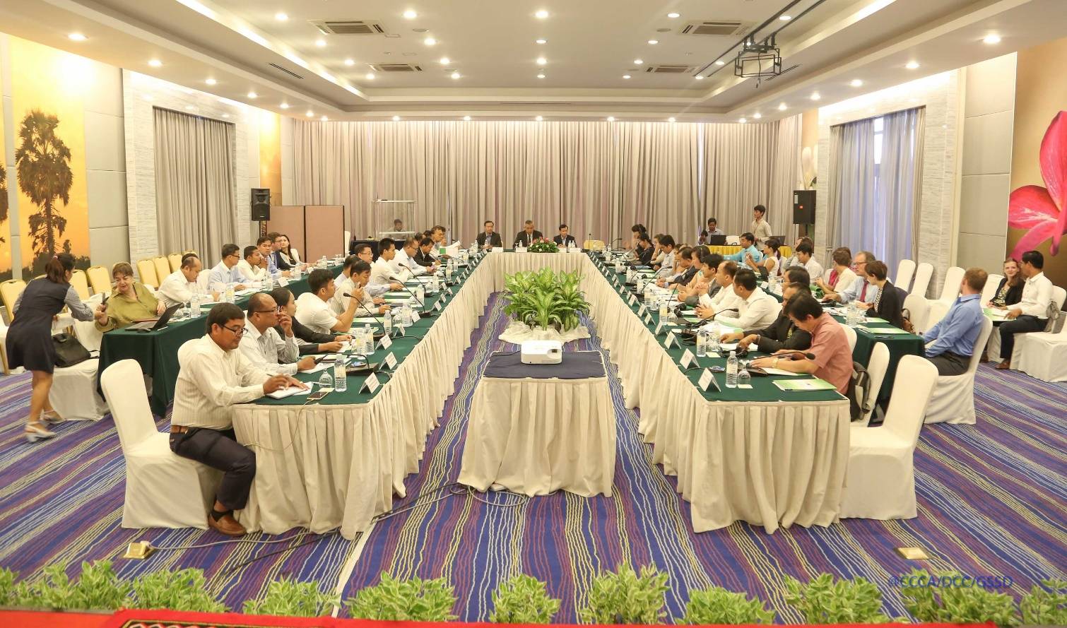
Photo 5: CC WTG meeting with DPs

Following the private sector scoping study in 2016, CCCA supported in 2017 a feasibility study on Payments for Ecosystem Services in the Kbal Chhay Protected Area in Sihanoukville province. Options for a PES scheme have been developed and potential sources of revenue identified, but further preparatory work is required in particular to better understand climate change and urbanization impact on the water reservoir, and to develop a management plan and budget for the area.

Output 2.2: NCCC Secretariat procedures updated and applied in line with the requirements for National Implementing Entities of multilateral funds

An operational manual for GSSD/NCSD was finalized by the ad-hoc technical working group of GSSD and adopted by the NCSD Secretary General. Department of Administration, Planning and Finance (DAPF) submitted the operation manual to Minister of Environment and Chairman of NCSD for approval and launching.

To support NCDD-S to become a Direct Access Entity (DAE) for GCF, CCCA is recruiting an international expert to help address accreditation gaps identified in the NCDD-S Operations Manual. It is expected that NCDD-S will be able to finalize its accreditation request in 2018.

Output 2.3: Climate change related expenditures are integrated into the government plans and budgets including the ODA database

Following recommendation of GSSD/NCSD, the Royal Government of Cambodia through Ministry of Economy and Finance (MEF) integrated climate change into BSP circular (2018-2020) and annual budget law circular 2018. The circular encouraged sector ministries to contribute to crossing-cutting issues such as climate change, gender, industrial development and DRR related issues. This is the second year in a row that climate change is explicitly mentioned in MEF budget circulars.

In line with the circular 2018, CCCA has supported infrastructure ministries (MRD and MPWT) to prepare their climate responsive budgets and plan with strong evidence through climate-sensitive cost-benefit analysis (CBA) and cost effectiveness analysis. Two reports including six case studies on climate sensitive projects of both ministries were produced by consultants to support the budget negotiation with MEF, and 14 officials were trained on using these tools.

The Climate Public Expenditure Review for fiscal year 2015 (CPER 2015) was approved by MEF and published in March 2017. The 2016 update has been completed and endorsed by MEF, it will be published in early 2018. The 2015 report is available for download on http://camclimate.org.kh /en/documents-and-media/library /category/39-financing.html

These two CPERs show a decline in international climate finance to Cambodia, while Government allocations have continued to rise. Overall, climate public expenditure was reduced from 1.1% of GDP in 2015 to 0.9% of GDP in 2016. A case study of the rural development sector also shows relatively low levels of alignment of climate expenditure with the climate change action plan of the ministry. This indicates the need to reinforce mainstreaming of climate change both in national budget system and in negotiations with development partners.

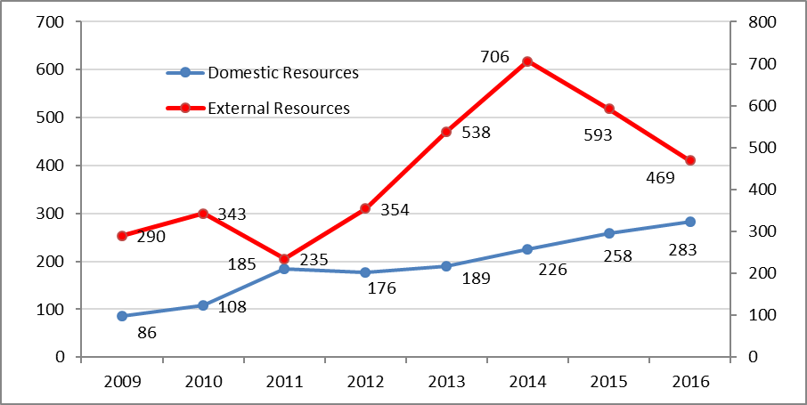
Figure 3: Sources of climate change public expenditure (CPER 2016, MEF)

In response to the request of Minister of MoE and Chairman of NCSD, Minister attached to Prime Minister and CRDB/CDC Secretary General accepted three suggestions of NCSD for continuous cooperation on external climate change finance: 1) NCSD was accepted and included in the list of government institutions to participate in consultations with Cambodia’s donors on their country strategies. H.E Tin Ponlok, Secretary General is a NCSD’s focal point and Mr. Ma Chan Sethea, Director of DAPF is alternative focal point. 2) Assigned technical staff of CRDB/CDC will provide support to set up a mechanism to automatically share ODA data related to climate change with DCC/NCSD’s climate change data portal. 3) NCSD staff will support CDC/CRDB staff to do quality assurance on the data of climate change-related projects, and to train donor focal points as required.
CRDB/CDC and DCC/GSSD have signed on a joint cooperation work plan (2017-2018). Four expected outputs will be delivered under work plan: 1) improvement of climate finance tracking in ODA database and data quality assurance, 2) integrate climate change into DPs country strategic plans, 3) Data analysis of external climate financial flows and 4) Capacity development to DPs related to climate change financing and how to tag cc finance in their projects.
Cooperation with the regional programme on Strengthening the Governance of Climate Change Finance to improve Gender Equality
A new phase of this regional programme was launched in Cambodia on 27th September 2018. Activities in Cambodia will focus on:
- Strengthening climate change and gender mainstreaming in the national budget cycle (with MEF)
- Strengthening selected line ministries’ capacity to submit climate and gender responsive budget proposals (at least MRD, MPWT, MOE), including through training (Economics and Finance Institute) and research (CDRI) partnerships;
- Supporting civil-society Government engagement on climate finance issues (with NGO Forum).
In 2017, CCCA cooperated with the regional programme to produce the first ever Climate Change Budget Integration Index (CCBII+), which will serve as baseline and indicator to measure progress made towards climate and gender responsive budgeting in Cambodia. The regional programme also supported the 2016 update of the Climate Public Expenditure Review.
The second major area of cooperation in 2017 is the ongoing modelling of climate change impacts on Cambodia’s economic growth, through the Climate Impact Growth Model. This exercise is led by Ministry of Economy and Finance / Department of Macro-Economic Policy, and modelling results are expected to be present by end February 2018. It is expected that findings and recommendations will inform the new Rectangular Strategy and Medium-Term Expenditure Framework.
Cambodia has been a pioneer for all three of these tools – in the case of the CPER since 2012 – which have been developed with methodological support from the regional programme.

Table 10: Summary of significant achievements for grants under Window 2:
# | Applicant | Project Title | Key Achievements | Key Planned Events | Challenges
1 | Ministry of Economy and Finance (MEF) | Economic and Public Finance Impacts of Climate Change | - MEF approved on final CPER 2015 and published.  - With inputs from GSSD/NCSD, RGC through MEF integrated CC into budget strategic plan circular 2018-2020 and circular on annual budget law 2018.  - Support MRD and MPWT to integrate CC into budget and planning process for 2018  - CPER 2016 completed.  - Annual review meeting on result of CC integration in budget and planning with MEF held.  - New LoA (Jan 2018- Jun 2019) drafted and processed for approval.  - Conducting research on Macro- Economic Modelling of CC impact. | - Publish CPER 2016  - Annual review meeting with MEF on two case studies (MRD and MPWT)  - Sign Amendment LoA with MEF for next phase.  - Complete analysis on Macro- economic modelling from CC impact  - Conduct CPER 2017 | N/A
2 | CRDB/CDC | Improve Cambodia’s tracking and mobilization of international climate financing | - Signed on join cooperative work plan 2017-2018 on climate finance tracking in ODA database.  - Presentation of the methodology of cc finance tracking in ODA database to DPs focal points  - CC finance tagging in ODA database has improved.  - ODA data shared with CPER consultant for analysis | - Provide feedback to CDC on their CC data (quality assurance).  - Provide capacity building as requested by CRDB  - Discuss with CRDB staff to on improvement of CC tagging in ODA  - Capacity building plan on GCF and CC financing for CRDB and DPs | N/A
3 | Ministry of Public Works and Transport (MPWT) | Supporting resource mobilization for climate change programme of MPWT through integration of climate change in budget submissions | - Signed LoA and programme of work with MPWT  - Conducted a study on pilot projects including cost-benefit analysis for road construction where sensitive to climate change.  - Two workshops delivered to discuss on findings of pilot study.  - Strengthen capacity of concerned departments under MPWT on CBA and cc responsive budget 2018  - CC integration in budget and planning for 2018 completed. | - Continuing support for cc integration into budget as required.  - Capacity development to concerned technical staff as requested from MPWT  - Additional study on inputs of CC into final BSP  - In cooperation with General Directorate of Policy and Planning of MPWT to integrate cc into new sector strategic plan and policy, and in screening tools for new projects.  - Support to raise the profile / communications of CC working group within MPWT | N/A
4 | Ministry of Rural Development (MRD) | Supporting resource mobilization for climate change programme of MRD through integration of climate change in budget submissions | - Signed LoA and programme of work with MRD  - Conducted a study on pilot projects including cost-benefit analysis for road/water infrastructure construction where sensitive to climate change.  - Two workshop delivered to discuss on findings of pilot study.  - Strengthen capacity of concerned departments under MRD on CBA and cc responsive budget 2018  - CC integration in budget and planning for 2018 completed. | - Continuing support for cc integration into budget as required.  - Additional study on inputs of CC into final BSP  - In cooperation with department of planning and public relationship of MRD to integrate cc into new sector strategic plan and its policy. | N/A

In the reporting period, CCCA made disbursements to the grantees under window 2 as summarized in table 8.

Table 11: Summary of financial management of CCCA grantees under Window 2:
N | Grantee | Total Budget | Disbursement (USD) |  |  | Expenditure (USD)
N | Grantee | Total Budget | In 2017 | To date | % disbursed | In 2017 | To date | % spent
01 | MEF | 70,000 | 55,000 | 70,000 | 100% | 55,000 | 70,000 | 100%
02 | MRD | 5,000 | 5,000 | 5,000 | 100% | 5,000 | 5,000 | 100%
03 | MPWT | 5,000 | 5,000 | 5,000 | 100% | 5,000 | 5,000 | 100%
Total |  | 80,000 | 65,000 | 80,000 |  | 65,000 | 80,000

Result 3: Strengthened human and technological capacities to support climate change response
Output 3.1: Standards and procedures for quality assurance of climate change awareness raising materials and knowledge management are developed
Finalization and implementation of a Knowledge Management Information System (KMIS):
CCCA has continued to support the development of a new online platform for climate change. Though serious issues with timely delivery of consultant’s products have resulted in a significant delay of the launch of the new platform, critical steps were performed in 2017. Notably, facilitated discussions amongst DCC, CCCA, and GIZ staff let to a clear definition on structure, functionalities and design of the new platform (which include a data portal for climate change related data and information). In addition, DCC/CCCA R3 team has worked together with the consultants on the migration of the existing camclimate content to the new prototype website on a temporary host server, while issues related to the overall structure of NCSD and GSSD website (including domain name) are being considered by GSSD. Camclimate will continue to run until the launch of the new website.

Standards and procedures for quality assurance of CC information are being developed alongside with the work on the knowledge management system and web platform. Prior to the migration of content to the new web platform, a preliminary screening for quality issues of existing information was conducted by CCCA; a subsequent QC will be conducted just prior to launching. QA/QC guidelines will be part of the SOPs for information management (documents and data) of the new CC web platform. ​

Camclimate remains one of the top online sources of climate change information and knowledge in Cambodia. Articles continue to be published and significant publications uploaded on a regular basis to the camclimate website and to the official MoE facebook page. During 2017, the website registered 23,396 visits, slightly less than the movements registered in 2016.

Figure 4: Annual website visits from 2013 to 2017

Output 3.2: Partnership with education institutions is established to integrate climate change into curriculum development and research

As part of the efforts to mainstream climate change into the secondary education curriculum, syllabus, standards and training materials for grades 10, 11 and 12 have been drafted by MoEYS with the support of CCCA. The work required significant revision of MoEYS initial drafts, both on structure and content of subjects to be covered, so that it would fit both targeted students and the existing curriculum on Earth Sciences where new CC subjects are to be included. Through the technical assistance from CCCA and DCC, training materials for grade 10, 11 and 12 have been finalized and will be discussed at a consultation meeting with key stakeholder early of 2018.

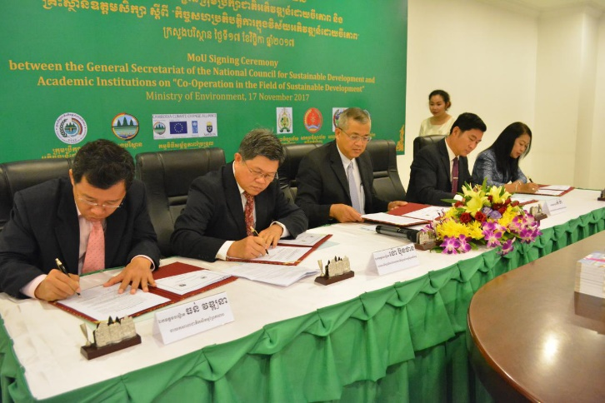
At the tertiary level, CCCA support is aimed at strengthening human capital and increasing policy research in the areas of climate change. In addition to making available research and innovation grants (discussed under 3.3), CCCA has sought to engage universities in climate change work through the establishment of continued formal collaborations between DCC/GSSD and targeted national research and academic institutions. Based on an initial assessment of the potential for collaboration between universities and DCC/GSSD conducted in early 2017, 6 universities were selected for further discussions regarding the establishment of a memorandum of understanding and programs of work with GSSD. On November 17, four universities, namely Royal University of Agriculture (RUA), Royal University of Phnom Penh (RUPP), Prek Leap National College of Agriculture (PNCA) and Meanchey University (MCU) signed MoUs with GSSD on strengthening the linkages between science and policy covering all four main areas of GSSD’s work (climate change, green economy, biodiversity, and science and technology). MoU discussions with two other universities, namely University of Heng Samrin Thbongkhmum (UHST) and Institute of Technology of Cambodia (ITC), will take place in 2018. In addition, at the end of 2017, three letters of agreement have been signed between CCCA and RUA, RUPP, and MCU, providing support to the implementation of activities included in programs of work for 2018.
Photo 6:MoU signing ceremony GSSD and university on Sustainable Development

Table 12: List of areas for cooperation under LoA with universities
University | Period of LoA | Focus Areas | Total budget
Royal University of Agriculture | 12 Months | Establish research thesis scholarships, knowledge sharing events, production of policy papers, organize a training on climate change impacts, vulnerability and adaptation assessments, develop a research grant proposal on climate change science and policy. | 14,000 USD
Royal University of Phnom Penh | 12 Months | Establish research thesis scholarships, knowledge sharing events, production of policy papers, develop a research grant proposal on climate change science and policy. | 6,300 USD
Meanchey University | 12 Months | Establish research thesis scholarships, co-organize with GSSD/CCCA one knowledge sharing event, knowledge sharing events, production of policy papers, develop a research grant proposal on climate change science and policy. | 7,500 USD

Output 3.3: Lessons generated from innovative practices pilots are documented and shared with relevant stakeholders

CCCA has continued to mentor DCC staff on capturing knowledge and lessons learnt from ongoing climate change interventions. One of the CCCA grantees projects – a women’s led project for improved access to safe drinking water in Kep and Kampot – has been used to provide hands on training on knowledge capture. With the data-gathering phase completed in 2017, the production of an in-depth case study on lessons learnt from this project is expected in the first half of 2018.

A significant focus of CCCA’s technical and financial support to climate change research and innovation has been provided through Window 3 of its Grant Facility. See the table 12.
Eight grants under window 3 on research and innovation are now operational; a summary of progress to date is presented in table 13
Table 13: List of approved projects under CCCA Grant Facility Window 3
# | Applicant and Partner Names | Sector(s) | Innovation / Research focus | Approved CCCA budget (USD)
1 | GERES  Partner: ITC | Industry, Energy, Agro-industry | Testing supply chain and technologies for use of biomass (palm fruit residue) for energy in garment and brick industries, and developing tools for investors | 91,000 USD
2 | National Bio-digester Program  Partner: Prek Leap National College of Agriculture | Energy, Agriculture | Testing technologies for medium-sized bio-digester (20 KW), and use of bio-digester slurry for adaptation in agriculture | 81,000 USD
3 | Cambodian Rural Development Team (CRDT) | Agriculture, Water, Energy | Integrated approach for farmer adaptation to CC: solar-powered water pumps, resilient crops and livestock, farmer organizations/SMEs | 91,000 USD
4 | General Department of Agriculture (MAFF)  Partners: RUA, ITC, CIRAD | Agriculture | Research on ecosystem benefits of conservation agriculture (on soil etc.) | 91,000 USD
5 | Wildlife Conservation Society  Partners: ITC, MOE GIS Department | Protected Areas / Forestry | Testing remote sensing monitoring of deciduous forest and grassland (focus on Kulen Phnomtep Wildlife Sanctuary) | 90,000 USD
6 | Ministry of Health  Partners: WHO, James Cook University | Health | Research to establish a climate vulnerability index in health sector  Development of CC vulnerability assessment tool for health | 91,000 USD
7 | NEXUS  Partners: ITC, MOE/NCSD and PP municipality | Waste management | Research on solid waste management (existing practices, international best practices etc.) and development of a strategy for Phnom Penh | 89,558 USD
8 | Provincial Department of Environment in Stung Treng  Partner: BDLink | Protected Areas / Ramsar site | Vulnerability assessment and adaptation strategy for communities leaving in an ecologically sensitive area (Ramsar) | 75,000 USD

Table 14: Status of achievement of grantees under window 3
# | Applicant and Partner Names | Sector(s) | Key Achievements | Challenges
1 | GERES  Partner: ITC | Industry, Energy, Agro-industry | - The project has started to quantify and map the biomass energy demand and supply in the garment industry through a preliminary desk review. The project made headway in the collection of primary data in the garment industries, through both electronic surveys and interviews with operational management of garment factories. The project is now looking to engage with other stakeholders (Association, Ministries, Institute of Statistics etc.) that could provide comprehensive and national data on the garment industry;  - H&M offered GERES an access to 11 factories within their network of suppliers and to existing primary data of the 50+ factories in their pool of suppliers. A partnership agreement is formally setting this arrangement;  - The project procured the machines (pellet, grinding, crushing, and carbonization furnace machine) required to produce the alternative fuel. The project has also defined the protocol and methodology for the future sampling and testing of fuel, which will start in February;  - For the garment industry, data has been collected and analysed and first lessons have emerged. Regarding the brick industries, the challenge is now to find a comprehensive and updated database that would allow to assess at the national level the demand in term of wood fuel. For the agricultural residues, after a preliminary review, project has been able to select the most relevant residues to study: rice husk, bagasse, empty fruit bunches (EFB) and corn cob.  - A garment factory (M&V) in Phnom Penh has agreed to let ITC and GERES use one of their boiler to proceed with the tests in real conditions. Hence 2 tonnes of Rice Husk Briquettes offered by Golden Daun Keo have been burnt in the boiler and the results were quite successful and have shown that they can replace wood without modification on the boiler. However longer tests would be necessary to confirm certain hypothesis and assess potential extra costs of using rice husk briquettes;  - Development of a NAMA on sustainable biomass fuels is in progress through consultations with the Ministry of Environment and Ministry of Mines and Energy. It is expected be ready to be submitted by the middle of March 2018.  - Project has led several interviews in Kandal province with brick producers to confirm the hypothesis that brick factories are currently starting to use more and more rice husk and less wood for the brick kilns. Indeed the study led by project team on the availability of agricultural residues suggested that the amount of rice husk used by brick factories is much more important than expected;  - Field visits have been done in the provinces of Battambang, Bantey Meanchey and Kandal with stakeholders of the agricultural sectors (farmers, processors and local authorities). A study tour has also been organized in the south of Vietnam (organized with support from another project) to better understand the use of Rice Husk Briquettes in the Vietnamese industrial sector. | Different types of briquettes and pellets have been produced in order to be tested in laboratory, but the pellets created didn’t have the right properties (too low density) to represent an interesting fuel to be tested in real conditions. That is the reason why the project team has considered that it would be more relevant for the project to test Rice Husk Briquettes produced by a local rice miller to proceed with the on-site tests in a garment factory.
2 | National Biodigester Program  Partner: Department of Agriculture of Kampong Speu Province | Energy, Agriculture | - 134 pig farms operate in Kampong Speu. Amongst these, 72 pig farms have technical potential for medium scale bio-digester plant which requires 500-2500 pig heads. The criteria, requirements and terms and conditions for the agreement with pig farms were developed.  - The innovative model design of medium scale bio-digester for piloting was developed by using AutoCAD software;  - A knowledge sharing meeting between NBP and UNIDO was conducted in order to share information on the largescale Bio-digester project of UNIDO which focused on farms with more than 4000 pig heads to produce 1MW electricity;  - During this period, 7 pig farms were visited to conduct the feasibility study for this project. As a result, two of them have been selected and have signed an agreement with the project;  - In terms of influencing policy development, the project has provided inputs into the policy on bio-digester development in Cambodia 2016-2025, which is being developed by the Ministry of Agriculture, Forestry and Fisheries, in particular to include medium and large scale bio-digester development;  - A Training Need Assessment (TNA) for Integrated Farming System farmers was conducted, where the piloting two medium scale bio-digesters are located. 47 farmers were selected to conduct individual interviews. The surveyed farmers provided their priority needs for capacity development, with soil management and natural fertilizer management as the most common need, followed by compost making, farmers field schools, chicken raising, techniques of bean plantation, cucumber and water convolvulus respectively;  - The project completed construction of three Lagoon medium scale biodigesters in order to store invented biogas for daily cooking purpose, and produce bio-slurry. Moreover, two electricity generators were linked with biodigesters in order to generate electricity for running cooling system in pig pens an cooking after the biogas is produced;  - The project team has conducted on-going monitoring visits and technical supports to the pig farm owners;  - Project completed construction of two compost store sites in order to provide compost demonstration on-site learning, learning by practicing in compost production training to key farmers and compost making with liquid bio-slurry and its applications.  - The 2 biogas storages for daily meal cooking were constructed and two bio-slurry storages with roofs within the two pig farm with the size 14.4 m3 were constructed near the lagoons;  - Project has conducted 3 compost producing trainings on-site to 45 key farmers, local authorities and PDAFF staff. Based on the field monitoring report, 14 of 41 key farmers have been applying the compost making learnt from the training;  - Project also selected a farmer household to construct one compost store for 3rd lagoon biodigester;  - The 3rd compost store is under construction to provide compost demonstration on-site learning, learning by practicing in compost producing training to key farmers and compost making with liquid bio-slurry and its application and particularly allow other potential farmers exchange their experiences on how to make bio-slurry compost and its application. For bio-slurry compost can play an important role as a source of nutrients for crop production and improving the quality of soil, the structure and texture of the soil enabling it to better retain nutrients and moisture; | - No major issues. Due to budget savings a fourth pilot site is under consideration.
3 | Cambodian Rural Development Team (CRDT) | Agriculture, Water, Energy | - The project organised two orientations in two target villages with a total of 47 participants (21 of whom are women) and one orientation meeting at district level with a total of 9 participants (2 women);  - The project conducted refresher trainings on group management. As a result, the community members drafted group by-law, and regulation and especially, more than 90 % of them have improved knowledge on concept of group (facilitation, leadership, vision, objective and role of group members) referring to pre-and post-training assessment;  - The project conducted four refresher trainings on financial management. As a result, more than 80% of participating community members have improved knowledge (on book keeping, lending, monthly saving records referring to pre-and post-training assessment);  - Land for model farms has been identified, as well as model farmers, and the farms’ activities have been agreed in a participatory manner;  - New training manuals have been developed on the concept of cyclical farms and the project conducted a workshop to introduce 10 model farmers (6 of whom are women) on cyclical agriculture farms concept.  - Three trainings on vegetable and mushroom growing techniques were organised for 14 model farmers (10 women);  - Two solar-powered water supply systems in target villages have been installed to support farming activities and improve access to water 41 vulnerable households have benefited from this water system. Two water management committees with three members in each committee have been trained on technical fixing on the water system and on how to record data of water usage;  - The project conducted 39 meetings with 4 CBOs with 78 participants (55 of whom are women) to strengthen capacity on better group management, leadership and book keeping. As a result, CBOs have improved their capacity on saving recording and committed to create small business on vegetable and livestock within their members;  - Project is facilitating the establishment of an Agriculture Cooperative (AC) for sustainable business model for farmers. The project team has conducted 2 meetings with 53 participants (39 of them are female) in cooperation with Kratie provincial technical department (Department of Agriculture) to provide explanation on the AC concept to operate potential agriculture business;  - Project provided 3 trainings on micro agricultural enterprise for a total of 48 CBOs members (43 of them are female) to provide the concept of enterprise on how to create small agricultural enterprise by using loan from their own saving group to increase their income;  - During this reporting period, UK tourists through CD Tour donated 2,400 USD to CBET and the money obtained was used to purchase two chicken homes and 20 heads of chicken for the poorest households in the villages, build a ladder for community, and support the construction of an iron fence to the model cyclical farm;  - For model farmers, the project provided 4 training courses on chicken raising with 14 participants (10 women) and also provided additional coaching on farm management, preparation of home garden with drip system and preparation fence for chicken houses. Moreover, project provided additional trainings on bookkeeping to 2 model farm cashiers so that they are able record the data of expense and revenue;  - The solar powered water supply system has supported 40 vulnerable households and generated a total of 399.75 USD from the water user fee and this money is being kept by the water user committee for maintenance, community development, and committee member wage as set in committee by-law;  - In collaboration with PDoA, project conducted two meetings to introduce Agricultural Cooperative law with 45 participants (33 women);  - Project conducted a market survey to identify potential business and network for agricultural products;  - Project team provided one training course on Leadership and bookkeeping to 11 SHG committee members (10 of whom are female);  - Project staff provided additional 21 coaching sessions to model farmers in both model cyclical farms with 14 participants (10 women);  - Project staff organized 3 meetings between seed supplier and CBO members, including model famers with 46 participants (40 women) in order to orient the CBO members about seed quality, expired date, and seed varieties which adapt with climate change and grow faster  - Project organized 5 training courses focused on vegetable growing (long bean growing) to climate change impacts to 4 SHG members with 42 participants (38 women). Moreover, 4 saving groups have saved a total of 14,403,200 riel (equivalent to around 3600.81 USD);  - The project organized one ToT training to 10 model farmers (8 women). After this training , model farmers also provided 2 training courses to others farmers with10 participants (10 women).  - In collaboration with PDA, project organized 2 meetings to set by-law to form Agriculture Cooperative with 60 participants (47 women). | Model farmers can’t work as regularly as required in model farms as they are busy with their domestic tasks
4 | General Department of Agriculture (GDA, MAFF)  Partners: RUA, ITC, CIRAD | Agriculture | - 5 staff from RUA, ITC, GDA/DALRM and CASC attended a regional training workshop in Thailand (as co-financing activity);  - The experiment fields on crop and cover crops sown with 2.5 ha of land, were established in order to compare conventional plough-based management and direct seeding mulch-based cropping systems.  - The 4th partner meeting was organized to share views, methods and tools to assess soil ecosystem services and (iii) to plan on-coming activities in Cambodia and for several locations;  - Two focus group discussions (with 55 farmers) were organized to share the knowledge with smallholders on paddy rice production managed under DMC and the utilization of fodder crops for livestock production. After the focus group discussion, all the participants were invited to join a farmer field day. In addition, experiments in the uplands and cover/fodder crop collections were also used for the field visit. As a result, 18 voluntary farmers with the total surface of 38.1 ha were interested in testing DMC on their own farm under the technical support from CASC;  - The Director General of the General Directorate of Agriculture visited the experiments and shared views with farmers in Banan and Rattanak Mondoul districts. This visit was an opportunity for CASC‘s team to present its activities and to emphasize the diversity of innovative cropping systems that are implemented and assessed and tested on-farm in the lowlands (upper sandy terraces and flood plains) and in the uplands (annual upland crops with maize and cassava);  - In partnership with Tokyo University of Agriculture and Technology (TUAT), a master student from the soil science lab of TUAT collected soil samples from soybean cropping system trial for the assessment of enzymatic activities; Soil and plant samples were collected at the Bos Khnor Station, Stung Chinit and Battambang in order to analyze the diversity of microbial communities between contrasted cropping systems (conventional plough-based management and DMC systems) and to identify contrasted trends in terms of abundance and diversity (fungi and bacteria);  - Soil sampling was organized in collaboration with RUA for assessing soil ecosystem services;  - Maintenance of the experiments in the Bos Khnor Research Station. As a result, cover crops were established and rolled down early June. Biomass was assessed on each plot;  - Participation to the 2017 World day to combat desertification that was organized at the Royal University of Agriculture (RUA);  - Main crops with maize, upland rice, rice-bean were established and two bachelor students from the Royal University of Agriculture are involved on such experiments;  - Soil samples were collected in the uplands of Battambang on the experiment conducted in the experimental site of Boribo;  - Lab analyses were conducted by the Bachelor students on the Soil Lab of RUA focusing on the quantification of labile-C pool, water-stable aggregate, and nitrate content. Soil and plants samples were also dried and stored for further analysis. In addition, team of ITC pursued plant analysis quantifying nutrients contents in plants for a range of species and mix of cover/relay crops. Moreover, a dataset is currently under progress aggregating data from the Bos Khnor Station, Stung Chinit and Battambang;  - During reporting period, main cash crops as maize, rice-bean and upland rice were harvested. As a result, the yields, above ground biomass were recorded. Besides the assessment of soil ecosystem services, soil insects were recorded every week using pit-fall trap. This assessment allows to characterize the diversity of insects on the top soil and on the litter. This is an additional information and indicators of the biodiversity that is enhanced under CA cropping systems when compared with conventional plough-based management;  - A training was first organized at the Soil Lab of RUA to adjust some methods based on existing tools and capacities. Three days sampling were then organized at the Bos Khnor Station and training was conducted at the same time. A group of 8 Bsc students were trained and involved on the soil sampling;  - The biofunctool which has been conducted is a site assessment of soil ecosystem services and the results were presented at the DCC/CCCA Knowledge sharing event. With this assessment, it is expected to produce an article to be submitted to an international journal; | No major issues
5 | Wildlife Conservation Society  Partners: MOE/GIS Department and USAID SERVIR Mekong | Protected Areas / Forestry | - The project started off with a hosted two-day training, in partnership with USAID SERVIR Mekong, on Google Earth Engine (GEE) with a total of 42 participants;  - The training meetings were held at the MoE Department of GIS to discuss MoE monitoring needs;  - With a process of establishing wildlife corridor areas to connect protected areas carried out by MOE, WCS provided technical support in aerial image interpretation to the MoE staff. Moreover, monitoring requirements specific to wildlife corridors are being integrated into the overall monitoring system design;  - Many software scripts written to produce analyses and data products on the GEE infrastructure. These include: 1) Basic Imagery Export for Landsat and Sentinel; 2) Cloud-free mosaics and greenest pixel; 3) Imagery transformations into indices (NDVI, EVI etc.) and 4) Time series analysis. These are the building blocks of the overall system that is being developed;  - A 10 terabyte network server for spatial data management was installed. A training session in the use of the server was also held. Subsequent training and storage design are scheduled throughout October;  - Project developed remote sensing data access tools, and land cover classification algorithms. The tools are intended to provide access to the advance capacity of Google Earth Engine (GEE) without requiring the end user to use computer program scripting methods previously required. This scripting requirement was identified in previous workshops and consultations with DGIS staff to be a major obstacle in using GEE;  - Project developed a refinement of satellite data selection tool for protected area landscapes, satellite image sorting and visualization tool (click through), random Forest machine learning algorithm development and Image interpretation data collection method development for trial;  - Project created public web access to the remote sensing tools and developed analytic capacity providing statistics;  - During reporting period, project has seen continued focus on technical development of remote sensing data access tools, and development of land cover classification algorithms and technical design of the overall application workflow;  - Project developed an analysis framework to view and compare deforestation rates as provided by the University of Maryland Global Forest Change dataset. Comparisons are for within projected areas and outside protected areas to provide measures of conservation success.  - A meeting with GDANCP was held to identify which work processes could be supported by this tool. GDANCP expressed strong interest and the final period of the project will focus on capacity development and inserting the tool in the day to day functions of GDANCP. | Need to adjust the activities to the strategy being developed for the MOE GIS department (with UNDP support), to ensure the users and added value of the tool developed are clear. This has now been done and the tool will be inserted in GDANCP regular activities for protected area management.
6 | Ministry of Health  Partners: WHO, and James Cook University | Health | - The project organized an inception meeting with a total of 23 participants (6 of whom are women) in order provide an overview of the project and outline the responsibility of different agencies, clarify management arrangements and discuss plan for communication, monitoring and evaluation;  - There was a mission from project partner, namely WHO to organize a consultative meeting on development of methodology for vulnerability index, including the literature review of existing research. As a result, a final draft of literature review was developed;  - 2nd visit mission of WHO expert was organized in order to review project progress, finalize plans for ongoing implementation of research project and further review of draft National Strategic Plan for Climate Change Adaptation and Disaster Risk Reduction for the Health Sector;  - A technical assistant has been recruited to provide expert data analysis and database management and specifically benefit the development of the Climate Change and Health Vulnerability Index for the project;  - MOU between MOH and WHO is finalized and signed;  - There was a mission from MPH Dept. of Global Health/University of Washington. As a result, a tool to assess the effectiveness of health adaptation to climate change was drafted;  - Project is under process to recruit the consultants to develop climate change and health vulnerability index; | Alternative arrangements have been made with University of Washington and individual consultant to support index development following the withdrawal of James Cook University
7 | NEXUS  Partners: ITC, MOE/NCSD and PP municipality | Waste management | - The project conducted desk review of current waste management contracts /master plans, existing reports, projects, policies;  - Best practices report (4 case studies) at local, regional or international level;  - An inception workshop was organised with 57 attendees (13 of whom are women);  - Signing of a trilateral MoU between PPCH, Nexus and project partner IGES;  - An introductory city‐level Technical Working Group meeting was conducted with 31 participants (district vice‐governors and representatives of line ministries);  - Recruitment of a new International Consultant;  - The second Technical Working Group (TWG 2) meeting with the city‐level stakeholders took place at City Hall with 35 participants;  - A Strategy Formulation Workshop (Milestone) Workshop co‐organized by IGES and Nexus took place with over 95 participants. As a result, a proposed Strategy Structure was drafted;  - A call for Expressions of Interest (EoI) was issued in order to collect ideas for a small‐scale demonstration project. As a result, 4 proposals were received and reviewed by NEXUS and City hall’s waste management division representatives. It was found that all the proposals were very relevant. Nexus and City Hall chose the UPWD-PIN implemented project for 2 poor remote communities in Meanchey and Dangkor districts of Phnom Penh suffering from lack of/insufficient waste collection. The contract is planned to be signed in July 2017;  - Two technical working group meetings on waste collection and landfill management were organised;  - Project signed a grant agreement with pilot project implementer UPWD to co‐fund the implementation of community focused waste management project in 2 communities around Boeung Tompun area, Dangkor district;  - Finalizing the second draft of the Strategy document and Action Plan;  - Start of community mobilizing activities of the pilot project “Community-based waste management initiative in Boeung Tompun”;  - Consultations with GGGI, CCCA and UNDP on funding sources (public, private, development funds) for the proposed strategy;  - Project review meeting with CCCA. | No major issues No-cost extension granted until end February.
8 | Provincial Department of Environment in Stung Treng  Partner: BDLink | Protected Areas / Ramsar site | - The project organised the kick-off meeting with a total of 35 participants, and the 1st meeting of project steering committee with 14 participants;  - 2-day workshop on SPSS was organised with 20 participants (11 of whom are women);  - The stakeholder engagement plan was prepared and used by the project when involving stakeholders during project implementation;  - A review literature on vulnerability assessment tools including vulnerability index and livelihood vulnerability index was completed and a VA methodology proposed;  - 200 note books with pictures and climate and gender educational statement were produced;  - Project conducted pre-test of questionnaire at the near-by village and then project collected primary data of vulnerability assessment from households in the target communes in order to construct the vulnerability index;  - The data from field survey has been entered and the analysis is under way. Moreover, the existing data (Climate Data) and climate-related section (temperature and precipitation) has been drafted;  - A training on climate change and vulnerability assessment was organised with 22 participants (12 women);  - Vulnerability assessment report was drafted;  - ^{3rd} meeting project steering committee was organised in order to inform the committee members including commune councils about the progress of the project and seek advice for further improvement;  - 2nd community workshop on assessment results and identification and prioritization of adaptation options;  - The meetings at village level were organised to select the target areas for piloting adaptation options. | No major issues

Table 15: Status of core indicators and targets of CCCA Research and Innovation grants for Window 3
Targets (output indicators only)* | December 2017 status
- At least 5 different types of adaptation activities and 3 different types of mitigation activities will be demonstrated, with 162 households as direct beneficiaries (at least 4% female-headed households and 7% ID poor households);  - At least 300,000 USD in public and private resources will be leveraged by CCCA grant projects for adaptation and mitigation activities;  - 120 provincial, national and local government staff will be trained on CC adaptation and/or mitigation (at least 20% female);  - 350 community members will be trained on CC adaptation and/or mitigation (at least 30% female);  - 30 knowledge products will be published  - At least 5 Government policies or regulations will take into account evidence produced by CCCA projects | - 7 types of activities (2 adaptation, 1 mitigation, 4 with both mitigation and adaptation benefits) are operational including solar powered-water supply system, cycle climate adapted agricultural techniques, saving groups for resilience and alternative business opportunities, strengthening Community-Based Ecotourism, lagoon medium scale biodigesters connected with electricity generator with use f bio-slurry for climate smart agriculture, community-based waste management initiative in Boeung Tompun, Conservation Agriculture cropping systems for the annual upland crops (maize, cassava, soybean), with 804 households as direct beneficiaries (including 20.9% female-headed and 12.9% ID poor households);  - 460,106 USD have been leveraged to date;  - 19 government staff trained (36.8% female);  - 47 community members trained (34% female);  - 13 knowledge products to date including e.g. vulnerability assessment for RAMSAR site in Koh Kong, agricultural training manual, architectural plan for medium-scale biodigesters, 4 posters on best practices in waste management, spatial assessment of the potential agricultural residues supply from agro-industries; spatial assessment of the woodfuels consumption and greenhouse gases emissions from garment and brick industries; technical feasibility report on palm EFB transformation into different kind of fuels, etc.  - 2 policies to date: Policy on Biodigester Development in Cambodia 2016-2025 and Solid Waste Management Strategy.

To date, 86% of window 3 budget was disbursed and 71% of the disbursement was spent, an improvement in delivery rates compared to 2016. The below table summarizes the financial management status of CCCA grantees under window 3 for research and innovation grants.

Table 16: Summary of financial management of CCCA grantees under Window03.

No. | Grantee’s Name | Total Budget | Disbursement (USD) |  |  |  | Expenditure (USD)
No. | Grantee’s Name | Total Budget | Disbursement (in 2017) | Disbursement (to date) | % of Total Budget | Expenditure (in 2017) |  | Expenditure (to date) | % of Disbursement
1 | CRDT | 91,000 | 48,548 | 70,878 | 78% | 30,371 |  | 46,322 | 65%
2 | GDA | 91,000 | 26,016 | 45,064 | 50% | 19,928 |  | 28,005 | 62%
3 | GERES | 91,000 | 64,372 | 91,000 | 100% | 45,113 |  | 68,437 | 75%
4 | MOH | 91,000 | 13,699 | 60,669 | 67% | 34,599 |  | 37,473 | 62%
5 | NBP | 81,000 | 60,710 | 81,000 | 100% | 46,623 |  | 55,249 | 68%
6 | NEXUS | 89,558 | 49,406 | 89,558 | 100% | 46,653 |  | 68,284 | 76%
7 | STDOE | 75,000 | 48,520 | 75,000 | 100% | 46,418 |  | 53,515 | 71%
8 | WCS | 90,000 | 70,820 | 90,000 | 100% | 46,401 |  | 69,885 | 78%
Total |  | 699,558 | 382,092 | 603,169 | 86% | 316,107 |  | 427,170 | 71%

These research and innovation grant projects, as well as projects receiving support from Windows 1 and 2 of the CCCA Grant Facility, as they near completion, are starting to provide a number of findings and lessons learnt that will be made available to all stakeholders mostly as knowledge products and awareness raising and communication materials.

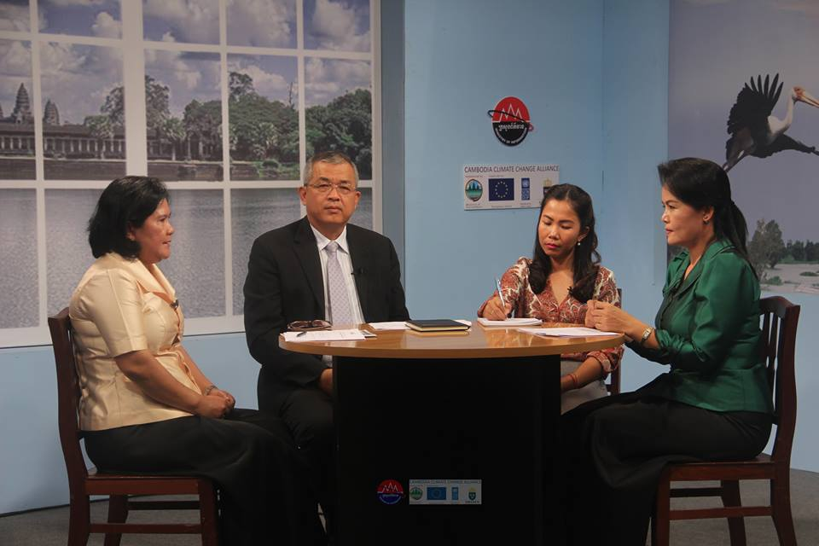
For example, the grant provided to MoInfo under CCCA’s grant Window I (round 2), has resulted in the production of talk show programmes dedicated to the discussion of climate change issues. Several 30 min talk shows and 10 min video features are being aired on Television Kampuchea (TVK) and National Radio. In 2017, two talk shows on “Low Carbon Development” and “Climate Change Response at Sub-National Level” and one video feature on “Climate Data and Information” were produced and aired on TVK; they counted with the participation of the GSSD representatives, related ministries/agencies, and members of the local community.
Photo 7: CC Video talk show at Television of Kampuchea

- Video feature on Climate Data and Information: https://www.facebook.com/mediaforclimatechangecambodia/videos/598931400472210/
- 1st talk show on Low Carbon Development: https://www.facebook.com/mediaforclimatechangecambodia/videos/590380334660650/
- 2nd talk show on Climate Change Response at Sub-National Level: https://www.facebook.com/mediaforclimatechangecambodia/videos/595314970833853/

The third talk show on “Climate-Smart Agriculture” is now under development and is expected to air in Q1, 2018.

DCC has also produced in 2017 a number of additional knowledge and communication products with the support from CCCA, including: Lexicon of Climate Change, developed in collaboration with the National Council for Khmer Language and containing 446 climate change related terms (publication and app launched on 25 April 2017, in a ceremony gathering 250 participants); KAP2 Video, an awareness raising video on climate change in Cambodia, based on the second national study on people’s perceptions, attitudes and practices towards climate change (the video is in its final stages of review/approval and should be launched in Q1 2018); Brief in Khmer on the National CC M&E Framework (official framework document is awaiting approval); 22 CCCA grantee project factsheets.

CCCA support to the dissemination of climate change knowledge in 2017 involved a wide range of efforts, including the organization of knowledge sharing and awareness raising events and other capacity development activities targeting youth.

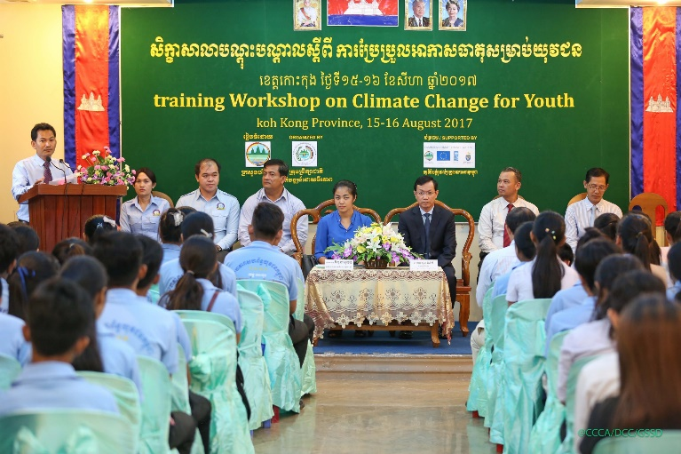
As part of the regular CCCA activities, two learning/knowledge-sharing events were organized:
(1) Learning Event on Sharing Experiences on the Implementation of Priority Climate Change Actions and Scaling-Up of Successful Approaches was held in Siem Reap Province on 7-8 June 2017, with participation of 22 CCCA-funded projects, climate change focal points from all concerned ministries, and representatives of other climate change projects. The event aimed to take stock of the progress made in the implementation of the CCCA grants, and discuss strategies to ensure these grants contribute to the scale-up of the climate change response in Cambodia. The need to ensure sustainability of the different project approaches, how to plan for scaling-up through public investment or market-based approaches, and strategies to make this happen were discussed by the participants. A market place exhibiting project briefs and publications for climate change awareness-raising was also included in the program;
Photo 8: CC Training for youth at Koh Kong Province
(2) Knowledge-Sharing Event on Research and Practice in Cambodia was organized in Siem Reap Province on 5-6 December 2017 and counted nearly 100 participants, including government representatives, development partners, academia, and NGOs. The event shared different perspectives from researchers, policy makers and practitioners and defined priority areas of research, contributing to setting a national research agenda for climate change.

Also part of DCC’s ongoing capacity development efforts, CCCA provided support to trainings mostly targeting Youth.
(1) Climate Change Training for Youth in Svay Rieng Province took place on 12th May 2017, counting with the participation of over 130 participants (including 61 women) and with the support of climate change professionals from DCC and CCCA. The event, presided by H.E. Tin Ponlok, NCSD’s Secretary General and H.E. Sum Socheath, Deputy Provincial Governor of Svay Rieng;
(2) Training Workshop on Climate Change for Youth in Kratie Province tool place on 15th December 2017 counting with more than 120 people including 53 women from Kratie youth, young leaders and students. The event was organized in collaboration with Kratie’s Provincial Administration;
(3) Climate Change Trainings for Youth and Under-Graduated Students, organized in collaboration with provincial administration offices and universities, took place at six different locations during 2017 and counted with a total of 884 participants, including 347 women. The training workshops in Kong Kong, Svay Rieng and Kratie targeted Youth, while those held at Heng Samrin Tbong Khmum (UHST), Prek Leap National College of Agriculture (PNCA), and Svay Rieng University (SRU) targeted undergraduate students.

Topics covered in the trainings included (1) causes and impacts, (2) national and international responses, (3) climate change adaptation measures, (4) mitigation options, (5) financial resources for climate change response, (6) climate change knowledge and information management, (7) carbon footprint calculation and (8) climate change terminology.
Figure 5: Number of participants in climate change trainings for youth and under-graduated students for 2017

DCC’s newsletter continued to be produced quarterly with the support of CCCA (both online and printed versions), with latest two issues awaiting publication (issue no.10 Jul-Sep is now in print and issue no.11 Oct-Dec 2017 is to be published in Feb 2018). The newsletter continues to contribute to the continued dissemination of a wide range of climate change related information amongst GSSD staff and other stakeholders, providing policy notes and coverage of ley events, as well as information on adaptation and mitigation best practices.

CCCA’s support to the World and National Environmental Day 2017 “Connecting People to Nature”, organized by the General Directorate of Environmental Knowledge and Information (GDEKI) of the MoE, held in Preah Sisovat High School on 17 June 2017, included the dissemination of climate change knowledge products in a dedicated booth, and the distribution of commemorative T-shirts to Preah Vihear Provincial Department of Environment. CCCA has also provided support to the organization of the GSSD workshop, part of MoE’s Annual Conference, contributing with commemorative materials and organizing media coverage.

Project Monitoring and Evaluation
The final report of the CCCA Mid-Term Evaluation was submitted early 2017 with the evaluation team submitting 16 recommendations, which were discussed at the 2017 board meeting and when relevant included in the CCCA Annual Work Plan.
Programme Annual Audit 2017: UNDP contracted KPMG to conduct an annual audit on CCCA from 1st January to 31 December 2016. KPMG submitted five findings and recommendations for the programme team to improve.
CCCA hosted two donor visits in 2017, one in Battambang (GDA project) and Oddar Meanchey (MOWRAM project) for the Swedish adviser on Climate Change and a delegation from the Embassy, and one on NCDM project on water and sanitation in Kampot province and NBP project on medium-scale biodigester in Kompong Speu for the EU Ambassador, UNDP Country Director and the press.

Capacity Development
Key areas of progress during the reporting period include:
- Monitoring and evaluation of the climate change response: through the process of updating the national institutional capacity indicators, Climate Change Technical Working Group members and DCC staff have gained technical knowledge about these indicators and are expected to be able to update these indicators annually, with minimum facilitation;

- Vulnerability analysis: with support from CCCA, two technical staff from DCC have acted as trainers of trainers for provincial, district and commune officials on vulnerability analysis as part of the local planning process, and gained concrete experience through implementation in pilot communes. In 2018, these two DCC staff members will take the lead for capacity development of local officials in new provinces;

- Climate-responsive budgeting: focal teams in both MRD and MPWT have acquired the skills for cost-benefit analysis of infrastructure projects in the context of climate change, and are able to use this data in negotiations with MEF;

- Coordination of the climate change response: from an institutional capacity perspective, 2017 saw major steps forward with the operationalization of the Climate Change Technical Working Group, and the six-monthly meetings of this group with development partners. Both structures have approved Terms of Reference (Prakas in the case of the CCTWG) and have been operating as planned. CCCA still provides technical support, but clear focal points have been appointed by DCC and are playing an active role in meeting preparations.

- Capacity development of grantees: this category is too diverse to be fully summarized here and it is largely covered in grant project updates above. Monitoring and evaluation of the grants indicate significant capacity development for CCCA grantees, from basic climate change project formulation and management capacities (through CCCA mentoring), to a variety of specific technical skills and guidelines, e.g. guidelines for diagnosis and treatment of climate sensitive diseases (MOH medical staff), development and implementation of climate-proofing standards for rural infrastructures (MRD engineers), implementation of GHG inventory methodologies for the transport sector (MPWT staff), community business skills for operating drinking water stations and advocacy campaigns (local communities under NCDM project), etc.
The main challenge for capacity development efforts has been the turnover of staff within DCC, beyond the control of management. This is due mostly to junior and mid-career staff leaving for post-graduate studies, reassignments within MOE/NCSD, or new careers. As of end 2017, new focal points for the M&E function and for climate finance work have to be appointed.
In other ministries/institutions, the key challenge is to be able to improve institutional capacity through mainstreaming of climate change in their key policy, programming and budgeting instruments. CCCA work with MRD, MPWT and MEF has shown promising results (impact on budget circulars and budget submissions), and with a new Government planning cycle starting in 2019, the CCCA team is confident that this work will lead to significant mainstreaming of climate change in the Rectangular Strategy, NSDP and sector strategies of these target ministries. Once these instruments are in place, they will provide the basis for scaling-up capacity development at individual level, beyond the climate change working groups in these ministries.
Efforts to strengthen the knowledge management function in GSSD/DCC are underway and a major focus of the 2018 work plan. There may be a need to strengthen GSSD/DCC staffing in this area.

Gender mainstreaming
The mid-term evaluation of CCCA in 2016 noted that gender concerns had been incorporated in grant formulation and management procedures, but called for a strengthening of the strategic engagement of ministries on gender aspects of the climate change response, beyond CCCA’s engagement with the Ministry of Women’s Affairs.
The main development in this area in 2017 has been the launch of the new phase of cooperation with the UNDP/SIDA regional programme on Strengthening the Governance of Climate Finance, with a specific focus on generating evidence on gender and climate change linkages through research (with CDRI), and feeding this evidence into the national budgeting and programming process, starting with the rural development sector. The first Climate Change Budget Integration Index for Cambodia, developed in cooperation with the regional programme, also includes a specific assessment of gender mainstreaming in climate change programmes and will serve as a baseline for future work.
Gender-disaggregated information on CCCA grants’ impact is presented in the reporting on grants.
A specific estimation of budget allocated to gender activities is difficult to provide as gender is integrated in activities rather than carried out separately. At a minimum this would include the work done with Ministry of Women’s Affairs (125,000 USD grant), as well as significant portion of the work done by several other grants (MOEYS, NCDM for example). As an example, 475 female-headed households have received support through CCCA grants in 2017, as well as 12 gender-sensitive eco-schools. Gender is also fully integrated in the methodology for vulnerability assessments for CCCA’s work at sub-national level under Result 1.

Environment and social safeguards
All CCCA grants go through environmental and social screening at formulation and approval stage, with risk management measures when required. A complaints mechanism is in place, disseminated during launch workshop and CCCA monitoring visits, and clearly advertised on all project sites (phone number and website reporting tool). CCCA has not received any complaints during the reporting period.

Innovation
Several innovative tools have been introduced in 2017 in relation to the climate finance work. This includes (i) the piloting (together with other countries in the region) of the Climate Change Budget Integration Index, with the Cambodia experience contributing to further refinement of the tool and methodology, and (ii) the first implementation of the Climate Change Impact on Growth Model (CIGM) with Ministry of Economy and Finance (ongoing with results expected by end February 2018). Further advocacy around both products is planned for 2018. This could confirm Cambodia’s status as a regional and global pioneer on climate change finance.

Lessons Learned
- Provincial Department of Environment staff have limited capacity in facilitation skill to facilitate the CC mainstreaming into Commune Development Plan process Therefore, DCC/CCCA support to them is time consuming;
- Along with CC mainstreaming into the annual commune development plan, the commune council at Koh Kong requested CCCA and PDoE to support and mainstream CC into their 3 years commune development plan;
- The perception of NCSD as an inter-ministerial entity (in line with the intent of the institutional reform) is not sufficiently gaining traction. MOE tends to present NCSD as one of its departments. In order not to compromise the future role of NCSD, the UNDP EGR project will need to address this issue when formulating strategies for HR development, communications, etc. ensuring a clear separation of roles and deliverables between e.g. MoE and GSSD/NCSD.
- Mainstreaming of CC into sectors’ legal frameworks will not be effective if solely relying on the usual consultation processes, which usually occurs at the final draft stages. A mechanism for the earlier review of legislation (both under review or development) led by CCTWG needs to be discussed and agreed to by the TWG in 2017.
- CCTWG discussions are leading to greater engagement of sector focal points, and contributing to new areas of work (e.g. monitoring mainstreaming of CC into Public Investment Plans, proposed by MoP as a joint activity with DCC).
- Efforts undertaken as part of the upgrade of the current CC website aiming at promoting CC related data and information sharing by government institutions through DCC’s website show that some ministries are more opened to share their databases than previously thought, even without requirements for formal data sharing agreements. MoP, CRDB/CDC, MoH are ministries that have already agreed to share their data bases and make their data accessible through DCC’s website. It is expected that their example can mobilize other sectors to do the same. However, obtaining data-sharing agreements for automatic sharing of information has been more difficult.
- Alignment of climate finance with ministerial CCAPs remains low. This points to the need to better mainstream climate change in the standard strategies and action plans of ministries, and to improve negotiation of climate-smart investments with development partners. The next generation of climate change plans should where possible move from separate CCAPs to full integration in sectoral strategies and plans. MRD and MPWT have already indicated interest for this and CCCA will support in 2018. The work programme with MEF will also help raise the profile of climate change in the next rectangular strategy.

Log Frame Analysis

PROGRESS TOWARDS COUNTRY PROGRAMME (CPAP) OUTCOME
UNDAF Outcome 1:
Outcome Indicators | Baseline (2016) | Target  (Dec 2018) | Current status (December 2017)
Government expenditure in climate change and environment protection (CCCA reporting on climate change expenditure only) | 1.4% of GDP (2014 data) | 1.18% | 0.9% of GDP (2016 data)

PROGRESS TOWARDS COUNTRY PROGRAMME (CPAP) OUTPUT
Output 1.2: Scaled-up action on national programme for climate change adaptation and mitigation across sectors that is funded and implemented, targeting the most vulnerable poor population.
Output Indicators | Baseline (2016) | Target  (Dec 2018) | Current status (December 2017)
Number of national scalable schemes/programmes for climate change adaptation and mitigation tested in the prioritized provinces that are climate vulnerable. | 0 | 4 | Not yet in place however several of the approaches tested under CCCA grants have potential to achieve this status by the end of the programme (mid-2019).

PROGRESS TOWARDS PROJECT RESULTS FRAMEWORK
Overall objective:

Indicators | Baseline (2014) | Target (2017) | Current status  (31 Dec 2017)
- % of CCAP annual requirement funded through budgetary and extra-budgetary resources | - No action (CCAP is being finalised) | - 30% | - 19.37%. This is based on the latest assessment conducted in cooperation with GIZ in early 2016.An update using data provided by CC-TWG members is expected to be available by mid 2018
- % of CCAP actions implemented with the support of the NCCC Secretariat or climate change working groups of line ministries | - No action (CCAP is being finalised) | - 30% | - 43% (43/101 CCAP actions) received some level of support through CCCA grants and implementing.  - A more in-depth reporting on the implementation of CCAPs is expected by mid 2018 (with input from CCTWG)
- CCCSP implementation on track (incl. process and impact indicators) | - The CCCSP is approved, national M&E framework is being finalized | 3) Annual improvement in CCCSP process and impact indicators | - National CC M&E framework has been launched, baselines published (except for GHG inventory), and the 2017 update has shown progress.  - NSDP indicators have been updated during NSDP’s mid-term review, and have shown improvement.

Result 1: Strengthening the governance of climate change

Outcome Indicators | Baseline (2014) | Target (2017) | Current status  (31 Dec 2017)
1.National M&E Framework is approved and functional including gender disaggregated and poverty indicators | 1.A draft M&E Framework is under discussion | 1. M&E Data collection and analysis in line with approved procedures | - National CC M&E framework finalized and launched.  - An official document of the national CC M&E framework in Khmer has been developed to ensure alignment of the different CC M&E efforts (submitted for final comment/ approval).  - Four CC indicators were included in NSDP 2014-2018, as well as one indicator on gender and climate change. The 4 NSDP CC indicators are now aligned with the national CC M&E framework through the reporting conducted as part of the NSDP MTR.  - Indicators for the upcoming NSDP will be developed during 2018.  - C-SDG 13 targets and indicators have been developed and endorsed by CC-TWG, ensuring the necessary alignment with the national framework and liaising with relevant sectors.
2.Number of ministries with institutional arrangement to manage their CCAP and contribute to CCTT activities | 2.Two line ministries have CC working groups (MoWA and MAFF) | 2. Seven line ministries | - All key ministries have focal points.  - Five ministries (including MAFF, MoWA, MRD, MoH, MPWT) have established climate change working groups or teams, with different levels of engagement. It should be noted that ministries which are more active at present seem to be those engaged in CCCA work (on CC mainstreaming of planning and budget instruments, or CCCA grant project implementation).  - A more in-depth reporting on the implementation of CCAPs is expected by 2018 (with input from CCTWG)
3.Number of ministries that demonstrate capacity to implement at least 50% of actions in their CCAPs and report on CCAP progress in line with national standards (incl. gender analysis) | 3.CCAPs is being finalized | - 3. Two line ministries | - n/a
4.Strengthen legal mandates for the NCCC, CCTT and NCCC Secretariat | 4.Institutional and legal review is ongoing | 4. Ministerial Prakas adopted in line with royal decree and sub-decree | - Royal decree on the NCSD and sub-decree on its General Secretariat were approved in 2015.  - Prakas on CC-TWG finalized and approved by Chair of NCSD.  - Two meetings of CC-TWG (one part of the coordination mechanism with development partners) were conducted in 2017.

Output 1.1: Legislation on climate change institutions, including roles of sub-national administrations has been strengthened
Output Indicators | Baseline (2014) | Target (2017) | Current status  (31 Dec 2017)
1.1.1 Status of the legislation on climate change institutions | 1.1.1. Institutional and legal review is ongoing | 1.1.1 Recommendations submitted to ministries/ agencies for at least 4 sectors/themes | - Royal Decree on NCSD and sub-decree on General Secretariat approved.  - Prakas on CC-TWG approved by Chair of NCSD  - CC Title included in the Environmental Code (to be early 2018).  - Guidelines for CC mainstreaming at the sub-national level endorsed by NCDD-S for the piloting phase.  - MoE integrated in the board of the new Sub-National Investment Fund.  - A revised draft on rules and procedures for carbon-offset mechanisms with inputs from GSSD has been submitted for final review/discussion with MEF prior to approval.
delivery exceeds plan | delivery in line with plan |  | delivery below plan

Output 1.2: National and key sectoral M&E frameworks are developed and submitted for approval
Output Indicators | Baseline (2014) |  | Target (2017) |  | Current status  (31 Dec 2017)
1.2.1 Status of National M&E Framework for Climate Change | 1.2.1 A draft M&E Framework is under discussion |  | 1.2.1 National M&E framework finalized and submitted to NCSD |  | - National CC M&E framework finalized (launched on April 7, 2016).  - The framework is part of the new legal framework for CC, set out by the draft Environmental Code.  - Khmer and English versions of the official framework document have been prepared and are now waiting clearance for publishing.
1.2.2 Number of sectoral M&E plans developed and submitted for approval by concerned ministries | 1.2.2 None |  | 1.2.2 Three |  | - 3 sectoral CC M&E frameworks developed namely MPWT, MAFF and MoH.
delivery exceeds plan | delivery in line with plan |  |  |  | delivery below plan
Output 1.3: Capacity of key line ministries has been strengthened to manage their CCAP and contribute to CCTT/NCCC activities
Output Indicators |  | Baseline (2014) |  | Target (2017) |  | Current status  (31 Dec 2017)
1.3.1 Number of line ministries that receive inputs for inclusion of climate criteria in planning/screening procedures |  | 1.3.1 None |  | 1.3.1 Three ministries |  | - Five ministries to date.  - Done for the MAFF 2016 budget submission, and with MEF for overall budget guidelines. MEF integrated CC into the Budget Strategic Plan and Annual Budget circulars.  - In 2016, follow-up support was provided to MAFF and training and hands-on support was provided to MOWRAM and MPWT, for their 2017 budget submissions. In 2017, follow-up support was provided to MPWT and hands-on support was provided to MRD. These ministries have prioritized CC-relevant projects as a result.
1.3.2 Status of capacity development programme for climate change officials in NCCC, CCTT, NCCC Secretariat and line ministry working groups |  | 1.3.2 Draft capacity development plan for NCCC, CCTT and DCC is available and only some activities are being implemented |  | 1.3.2 Tailored training programme delivered (1st round) for Govt officials |  | - An overall capacity assessment of NCSD and its Secretariat, based on the new institutional arrangements and mandates, is being conducted by the Environmental Governance Reform Project (ERG, UNDP) and it is expected to be completed in Q1 2018. CCCA will provide CC focused support during the capacity assessment phase and will contribute to the development of the capacity development plan and delivery of training programs in 2018.  - Capacity building/mentoring to DCC, CCTWG and GSSD/NCSD members is ongoing, in particular on M&E and CC mainstreaming in subnational planning and budgeting processes (CIPs).
1.3.3 Number of line ministries producing annual CCAP monitoring reports |  | 1.3.3 None |  | 1.3.3 Three ministries |  | - Templates for CCAP reporting have been prepared.  - Official request to the relevant 14 institutions has been sent and the assessment exercise is currently taking place (expected to be completed in Q1/2 2018)
1.3.4 Number of line ministries/agencies’ receiving CCCA grant support for the implementation of CCAP priority actions |  | 1.3.4 None |  | 1.3.4 Seven ministries |  | - 14 Ministries/agencies receiving grants from CCCA to implement their approved CCAPs
delivery exceeds plan |  | delivery in line with plan |  |  |  | delivery below plan

Result 2: Domestic and external finance effectively oriented in support of climate resilient, and low carbon development
Outcome indicators | Baseline (2014) | Target (2017) |  | Current status  (31 Dec 2017)
- Status of government – partners coordination mechanism | 1. No formal mechanism in place | 1. Coordination mechanism is functional |  | - Two CCTWG and DPs meeting were held in 2017  - TOR CCTWG and DPs has been agreed and approved
- Status of Cambodia’s direct access to Multilateral climate funds | 2. No direct access | 2. Accreditation request submitted to one fund |  | - Two are in the pipeline (NCSD and NCDD), but some changes to procedures and time to demonstrate a track record are required before the NCSD applications can be submitted. NCDD has undergone an initial assessment from GCF and is receiving support from CCCA to address some gaps. It should be able to apply by end 2018.
- Number of ministries benefiting from NCCC Secretariat support on financing sourcing and modalities | 3. Four (MOWRAM, NCDD, MAFF, MOE) | 3. Seven ministries |  | - 8 ministries and agencies. MAFF, MPWT, MRD and MOWRAM (domestic budget), NCDD-S (GCF access), MOE (LDCF/GEF projects), MOH/WHO (LDCF access), CDC/CRDB (training on all sources/modalities) + UNITAR/EFI training to 6 ministries (MAFF, MOWRAM, MPWT, MOE, MRD, MOH, MEF).
- Status of public-private dialogue on climate change investments | 4. No formal mechanism in place | 4. Recommendations in at least one thematic area |  | - Mapping of private sector contribution to CC completed, including recommendations for a dialogue mechanism.  - Feasibility study on PES in Kbal Chhay has been finalized.
- Number of ministry planning and budgeting documents explicitly integrating CC |  | 5. Seven ministries |  | - Six ministries. MPWT’s CCAP is fully reflected in their PIP and partially in their 2017 and 2018 budgets.  - MAFF and MOE budget submissions for 2016, 2017 and 2018 integrate CC, with support from CCCA (and GIZ for MOE)  - MOWRAM’s CCAP is partially reflected in their 2017 budget submission.  - MRD’s CCAP is partially reflected in their 2018 budget submission / BSP.  - MEF’s budget and BSP guidelines include clear references to climate change.
Output 2.1: Coordination mechanism is established and functional for climate change domestic and external finance and investments
Output Indicators | Baseline (2014) |  | Target (2017) | Current status  (31 Dec 2017)
2.1.1. Status of government-donor coordination mechanism | 2.1.1. There is no formal government-donor coordination mechanism |  | 2.1.1. Regular meetings | - Regular meetings held every 6 months (June and November 2017)
2.1.2. Status of mechanism for NCCC-Secretariat to respond to requests from line ministries and other stakeholders for financial and technical support on CC finance | 2.1.2. Not established |  | 2.1.2. Mechanism provides effective response to stakeholders’ requests | - Director of DAPF acts as focal point for requests on climate finance. The newly established CC-TWG provides a forum to gather these requests for support.  - Factsheets on climate funds and how to access them have been finalized.  - CCCA provides ongoing support to NCSD in its role to support the Green Climate Fund NDA role
2.1.3. Availability of dialogue platform with private sector on climate change | 2.1.3. Not established |  | 2.1.3. At least one event held in line with agreed programme | - First consultations held in 2016,  - Private sector representatives have been included in the coordination mechanism on CC  - PES consultations planned for Q1 2018
2.1.4. Percentage of NCSD, CCTT and NCSD Secretariat staff participating in preparations and involved in international negotiations on CC | 2.1.4 TBC |  | 2.1.4. 80% for CCTT(CCTWG)/Secretariat and 50% for NCSD | - 80% of CCTWG (20CCTWG member/25) and 17% of NCSD members ( 11 NCSD members/63)
delivery exceeds plan | delivery in line with plan |  |  | delivery below plan

Output 2.2: NCCC Secretariat procedures updated and applied in line with the requirements for National Implementing Entities of multilateral climate funds
Output Indicators | Baseline (2014) | Target (2017) | Current status  (31 Dec 2017)
2.2.1. Status of NCCC secretariat procedures | 2.2.1. The first version of NCCC secretariat procedures is under pilot implementation | 2.2.1. Procedures consistently applied, as confirmed by annual audit | - Procedures applied, approval by Minister required
delivery exceeds plan | delivery in line with plan |  | delivery below plan

Output 2.3: Climate change related expenditures are integrated into the government plans and budgets including the ODA database
Output Indicators | Baseline (2014) | Target (2017) | Current status  (31 Dec 2017)
2.3.1. Status of CC expenditure reviews against national CCAP | 2.3.1 First Climate Public Expenditure and Institutional Review conducted in 2012 and updated in 2013 | 2.3.1. Annual updated expenditure review available and mapped against CCAP | - Climate Public Expenditure Review for fiscal year 2015 (CPER 2015) has been finalized by MEF. The CPER for 2016 is approved, to be published in 2018.
2.3.2. Quality and application of climate change tag in the ODA database managed by CDC/CRDB | 2.3.2. Climate change tag not consistently applied in the ODA database | 2.3.2. Use of CC tag by ODA database users improves | - Thematic marker in ODA database is more specific. Sector classification has also been adjusted to track “new and additional” CC finance. Guidance developed for donor focal points, who have been trained by CDC/CRDB and GSSD. A quality assurance exercise has been conducted by NCSD in July 2017 and communicated to CDC/CRDB.
2.3.3. Number of knowledge products on cost-benefit analysis of the climate change response in Cambodia | 2.3.3. Initial estimates and case studies integrated in the report on Climate Change Financing Framework (2014) | 2.3.3. One knowledge product available | - 17 case studies produced to date, including 6 new ones in 2017.
delivery exceeds plan | delivery in line with plan |  | delivery below plan

Result 3: Strengthened human and technological capacities to support climate change response
Result Indicators | Baseline (2014) | Target (2017) | Current status  (31 Dec 2017)
- Status of procedures for management and exchange of climate change related information | A climate change website exists but key data bases remain scattered | A metadata base listing climate change related information is functional and publicly available | - A consultancy firm is currently working on the development of the CC portal, including the transfer/ restructuring of the existing Camclimate.org.kh content, and development of the data portal (initially with 3 data products). A Khmer CC Lexicon (database of CC related terms, definitions and acronyms) has been created and is now accessible via internet or mobile devices.
- Status of integration of climate change in schools and universities’ curriculum | KMIS framework and action plan have been finalized and are now being operationalized  Database management consultancy arrangements are delayed. | Primary and secondary curriculum completed. Partnerships with at least 2 universities in place | - CC integration in secondary school curriculum is ongoing, under the MoEYS and MOWA grants.  - GSSD signed MoUs with four Universities (RUA, RUPP, PNCA, MCU)  - 3 LoA have been signed with RUA, RUPP and MCU for implementation of a program of activities designed with CCCA for the first year of MoU implementation.  - Two lectures on CC to Heng Samrin Tbong Khmum University and Svay Rieng University (adhoc interventions)
- Mechanism is in place to identify and test relevant technologies for CCAP implementation | There is no mechanism in place | NCCC Secretariat monitors at least 6 projects with a focus on innovation | - DCC/GSSD is currently monitoring the implementation of window 3 related projects, as well as MoE window 1 project (electrical motorbikes)
- Availability and functionality of standards and quality assurance procedures for climate change publication and data | Not available | Standards and quality assurance procedures are in place and functional | - DCC QA and QC procedures for CC relevant knowledge products/ publications (including awareness, communication and knowledge products) will be part of the SoP for the management of the CC online platform, currently being drafted. Guidance on QA/QC procedures for data products will also be part of the same SoPs.

Output 3.1: Standards and procedures for quality assurance of climate change awareness raising materials and knowledge management are developed
Output Indicators | Baseline (2014) | Target (2017) | Current status  (31 Dec 2017)
3.1.1. Status of standards for awareness-raising on climate change | 3.1.1 Not established | 3.1.1. Standards for awareness-raising on CC approved by NCSD | - See number 4 above.
3.1.2. Status of quality assurance procedures of key CC materials and technologies | 3.1.2. Not established | 3.1.2. QA procedures implemented | - See number 4 above.
3.1.3. Status of a protocol for management and exchange of climate data | 3.1.3. Not established | 3.1.3. Protocol implemented | - See number 4 above.
delivery exceeds plan | delivery in line with plan |  | delivery below plan

Output 3.2: Partnership with education institutions is established to integrate climate change into curriculum development and research
Output Indicators | Baseline (2014) | Target (2017) | Current status  (31 Dec 2017)
3.2.1. Number of partnerships with universities on CC curriculum development and research | 3.2.1. No comprehensive partnerships in place, but three academic institutions have been involved in CCCA pilots projects (RUA, RUPP and PNCA) | 3.2.1. Two partnerships under implementation, one new partnership in place | - 4 universities have been selected Royal University of Phnom Penh, Meanchey University, Royal University of Phnom Penh and Prekleap National College of Agriculture (PNCA) and respective areas for partnership development identified. MoUs sign between GSSD and those 4 universities.  - 3 LoA signed between CCCCA and RUA, RUPP and MCU follow to agreement of programme of work for implementation MoU
delivery exceeds plan | delivery in line with plan |  | delivery below plan

Output 3.3: Lessons generated from innovative practices pilots are documented and shared with relevant stakeholders
Output Indicators | Baseline (2014) | Target (2017) | Current status  (31 Dec 2017)
3.3.1. Number of sectors/sub-sectors who have piloted innovative practices with support from CCCA grants | 3.3.1. 0 | 3.3.1. Four | - Eight grants have been approved in June 2016, covering six sectors: agriculture, rural development, sustainable energy, waste management, health, protected area management.
3.3.2. Number of knowledge products from research initiatives in key sectors | 3.3.2. 0 | 3.3.2. Two knowledge products | n/a
3.3.3. Number of knowledge sharing events for CC practitioners, researchers and policy-makers | 3.3.2. 1 per year | 3.3.3. Two knowledge sharing events | - 2 knowledge sharing events held in June and Dec 2017 in Siem Reap. Learning event proceedings have been shared with stakeholders and made available by online.
delivery exceeds plan | delivery in line with plan |  | delivery below plan

Project implementation challenges

Project issues
  - Some of the selected communes for mainstreaming CC into their action plans have seen a change in personnel due to recent commune elections 2017 and subsequent changes in December 2017. Some retraining and engagement of their new staff will be required and may cause delays.
  - Several of the grants contracted in early 2017 have had start-up delays, mostly due to procedures for approval of their project bank accounts by MEF. This is now resolved but projects still need to catch-up.
  - Delayed recruitment process of Knowledge Management Officer (KMO) led to delay in some activities; resignation of the Technical Officer may translate in slight delays in 2018.
  - Limited capacity of PDoE staff in supporting the mainstreaming of CC into CIPs has led to additional CCCA staff time required to support the process;
  - Some grantees of Window 1 Round 2 reported delays in the project start-up phase, due to administrative processes in getting approval for project bank accounts from Ministry of Economic and Finance.
  - Consecutive delays related to the consultancy on web design and database management has resulted in termination of contract and in the engagement of a different firm to complete the assignment.
  - During the reporting period, the Knowledge Management Officer resigned from his position (moved to a new post). Ms. Reaksmey Neou was selected for this position through the recruitment process in December 2017;
  - The Climate Change Technical Officer who was recruited in February, resigned by the end of November 2017.

Risk log (See Annex I)

Financial Status and Utilization
Table 17: Contribution Overview
 | Donors | Committed | Received |  | Balance
 | Donors | Committed | Original Currency | USD * | Balance
1 | SIDA | SEK 28,000,000.00 | SEK 23,000,000.00 | 2,838,168.91 | 563,697.86
2 | EU | EUR 6,000,000.00 | EUR 4,485,382.00 | 5,011,966.90 | 1,838,128.64
3 | UNDP | USD1,394,380.50 | USD1,393,813.50 | 1,393,813.50 | -
 | TOTAL | USD 11,645,776.00 ** |  | 9,243,949.00 | USD 2,401,826.00 **
* Based on the exchange rate on the day the contributions were received.
** May change based on the exchange rates when receiving the balance contribution from EU/SIDA in the future

Table 18: Annual Expenditure by Result [1Jan - 31 Dec 2017]
RESULT | 2017 | 2017  Expenditure  (Jan-Dec) | Balance | Delivery
RESULT | Approved | 2017  Expenditure  (Jan-Dec) | Balance | (%)
RESULT | Budget | 2017  Expenditure  (Jan-Dec) | Balance
RESULT 1: A clear governance and accountability framework is functional for the climate change response at national and sector levels. [iii] | 1,399,967.00 | 1,447,096.06 | (47,129.06) | 103%
RESULT 2:Public and private resources are leveraged and managed efficiently, in support of climate resilient, and low carbon development [iii] | 455,004.40 | 354,621.50 | 100,382.90 | 78%
RESULT 3:  Strengthened human and technical capacities to support climate change response [iii] | 1,041,997.43 | 980,874.05 | 61,123.38 | 94%
Total | 2,896,968.83 | 2,782,591.62 | 114,377.21 | 96%

Table 19: Cumulative Expenditure by Result [1Jul 2014- 31 Dec 2017]
RESULT | Total | Cumulative | Balance | Delivery
RESULT | Project | Expenditure | Balance | (%)
RESULT | Budget |  | Balance
RESULT 1:  A clear governance and accountability framework is functional for the climate change response at national and sector levels. [iii] | 5,883,912.78 | 3,868,292.71 | 2,015,620.07 | 66%
RESULT 2: Public and private resources are leveraged and managed efficiently, in support of climate resilient, and low carbon development [iii] | 1,748,059.13 | 1,072,020.73 | 676,038.40 | 61%
RESULT 3:  Strengthened human and technical capacities to support climate change response [iii] | 3,442,040.15 | 2,277,292.81 | 1,164,747.34 | 66%
Total | 11,074,012.06 | 7,217,606.26 | 3,856,405.80 | 65%

Supporting documents

Prakas on Climate Change Technical Working Group

Report on Climate Public Expenditure Review for fiscal year 2016 (CPER 2016)

Proceeding of the sharing experience on the implementation of priority climate change action plan and scaling up of successful approached.
- Proceeding for the sharing experience on the CC research and practice in Cambodia

Work-Plan for 2018
A summary of key activities under each result is presented below:
Result 1:  A clear governance and accountability framework is functional for the climate change response at national and sub-national levels. | Output 1.1: Legislation on climate change institutions, including roles of sub-national administrations has been strengthened
 | Legislation on climate change institutions
- Support the annual NCSD meeting
- Support GSSD to establish the Sustainable development at sub-national in particular for climate change sector
- Support Climate Change Technical Working Group and it’s operation
 | Mainstreaming CC into related core legislation
- Support the GSSD to work with MoI/NCDD to update the TOR and structure of the Provincial Inter-Sector Office and PDoE to include the function on sustainable development, especially for climate change
- Support CC integration in priority pieces of legislation: MoE on the Environmental Code.
 | Definition of appropriate levels of intervention for various types of CC activities under the decentralization and deconcentration framework
- Capacity development and operational support to PDoEs in their advisory role to communes/districts on climate change (3 additional provinces and 12 additional communes in 2017;
- Supports to 6 commune investment plan in 6 communes in 3 provinces

 | Legal framework for Carbon Finance
 | - Support to approval of Code (CC section), sub-decree (establishment of DNA), prakas on management of results based climate finance including carbon finance.
 | Output 1.2: National and key sectoral M&E frameworks are developed and submitted for approval
 | M&E system operationalization and TA to M&E unit in DCC and line ministries
- Formally establish the DCC M&E team as part of GSSD M&E team (designation of DCC/GSSD team members and development of TORs)
- Prepare MoU/Data sharing agreement with MoP (CDB data) and streamline production of relevant CC indicators
- Design a program of work for capacity development activities targeting DCC/GSSD M&E team and TWG reps (in coordination with UNDP and SPCR relevant capacity needs assessment activities, and as part of the
- Support the DCC/GSSD team in the development of SDG 13 and NSDP CC related indicators [*budget for 4 internal meetings on SDG13; 2-day meeting/retreat for new NSDP indicators (DCC/GSSD and sectors)]
 | UNFCCC reporting requirements
- Provide TA support to DCC to Prepare TNC and BUR
- Organize workshop to disseminate CoP23 result
- Develop the Cambodia Position for negotiation in COP 24
- Support Cambodia Delegation to attend COP 24 and the 48th Subsidiary Body for Implementation (SBI 48) and Subsidiary Body for Scientific and Technological Advice (SBSTA48)
- Organize workshop to dissemination result of COP24
 | Output 1.3: Capacity of key line ministries has been strengthened to manage their CCAP and contribute to CCTT/NCCC activities
 | Provide inputs to line Ministries for inclusion of climate criteria in planning and budgeting procedure
 | - Covered under result 2.
 | Capacity support for CC institutions
- Prepare capacity assessment and development plan for relevant ministries [This will be based on results from the assessment provided during the CCAP reporting exercise and the capacity assessment being conducted by the EGR project]
- Conduct V&A Training for CCTWG (line ministries)

 | Capacity support to line ministries in CCAP development and reporting
- Training to TWG on CCAPs reporting
- Produce report on level of CCAP implementation by line ministries
- Develop NDC implementation plan
 | Grant support to line ministries/agencies from CCCA for implementation of CCAP priority actions
- Organize GIG Training to grantees
- Management of the existing 14 grants to ministries, including spot checks and monitoring visits
- Organize Grantee learning event
- Organize 4 manager monitoring on grantees
- Organize CCCA Donor visit
Result 2: Domestic and external finance effectively oriented in support of climate resilient, and low carbon development | Output 2.1: Coordination mechanism is established and functional for climate change domestic and external finance and investments
- Organize two CCTWG and DPs meetings
- Respond to requests for support on accessing climate finance and monitor demand for these services (accessing GCF, AF, NIE)Map private sector contribution to the CC response and identify concrete measures to facilitate climate-smart investments;
- Support pilot design process on Payment for Ecosystem Service (PES) in Kbal Chhay water fall, Sihanouk province. A local consultant would be recruited to support this process.
- Feasibility study on Policy Incentive for low emission vehicles
- DCC or CCTWG staff to participate in CC negotiation at regional level.
- Organise regional workshop among ASEAN countries to share experience on climate change mainstreaming.
 | Output 2.2: NCCC Secretariat procedures updated and applied in line with the requirements for National Implementing Entities of multilateral climate funds
- Provide training on GSSD/NCSD operation manual for both government and donors fund to staff
- Support preparations for accreditation of Cambodia NIE(s) to the Adaptation Fund and Green Climate Fund, including strengthening of internal audit function
- Co-finance for international consultant to support GCF accreditation process of NCDD-S
 | Output 2.3: Climate change related expenditures are integrated into the government plans and budgets including the ODA database
- LoA with MEF (amendment LoA) until June 2019 including CC integration into BSP and annual budget circular 2019-2021Identify potential South-South , north-south learning opportunities at SS or minister level
- Analyse CC data in ODA database, integrate in CC expenditure reviews, and provide feedback to CDC/CRDB
- LoA with MPWT on integration cc into their sector strategy and plan 2019-2023Provide support CBA and climate responsive budgeting for 2018 to MRD (Grant to MRD plus national and international consultant)
- Dialogue with Private Sector
Result 3: Strengthened human and technical capacities to support climate change response | Output 3.1: Standards and procedures for quality assurance of climate change awareness raising materials and knowledge management are developed
- Finalization and implementation of a Knowledge Management Information System (KMIS), including inventory of GHG reduction projects and database on Vulnerability Assessments
- Provide Vulnerability Assessment training to CCTWG
- Conduct climate change vulnerability and adaptation assessment to critical sectors
- Implementation of standards QA/QC procedures for CC data, information and knowledge products;
- Develop CC awareness raising materials;
- Implement protocol for data, information and knowledge management;
 | Output 3.2: Partnership with education institutions is established to integrate climate change into curriculum development and research
- Integration of CC into secondary education curriculum through the grant project with MoEYS
- Establish partnership with universities and research institutions, participating in KMIS, QA mechanism, agenda setting for CC research
- Conduct research on heat impacts on health and productivity
- Launching the training curriculum 10-12
- Provide training on climate change to youth at Phnom Penh and 3 at sub-national
 | Output 3.3: Lessons generated from innovative practices pilots are documented and shared with relevant stakeholders
- Manage and monitor 8​ research & innovation grants (agriculture, rural development, sustainable energy, waste management, health, protected area management) Produce case studies and good practices of selected grants;
- Top up some requested activities from grantee, Geres, NBP, CRDT and potentially GDA
- Produce communication and knowledge products (Visual-Audio &Print Prod Costs) (Produce KAP2 video and improve the UNEP video);
- Publish the brief of Paris Agreement;
- Publication: CC Newsletter, CC posters, M&E framework in Khmer;
- Organize at least two knowledge sharing events, including CC component of MoE annual Forum;

Annex I: Risk Log
# | Description | Date Identified | Type | Impact &  Probability | Countermeasures / Management response | Owner | Submitted, updated by | Last Update | Status
1 | Government staff capacity is not fully available for programme implementation due to other tasks (other than CCCA) and lack of sufficient national monetary incentives.  (across results) | 15 Feb 2014 | Operational | P: Medium  I: Medium | This programme is designed with a recognition of this risk. The CCCA will fully align with national arrangements, and Government staff will be engaged in line with their official functions and TORs, to minimize extra project-related tasks. Where additional support is required, project-financed personnel will be deployed to work in twinning arrangements with government project counterparts. The Government has committed to make available sufficient Government staff for programme implementation. Non-monetary incentives will be promoted through the implementation of the Capacity Development programme that was developed in CCCA phase 1. The CCCA will also stand ready to follow the Government/ Development Partner/ EU member states policy for incentive system (if re-established) and apply it as soon as available. | MoE/CCD | NPM | Dec 2017 | No change
2 | Cross-sector coordination and joint programming involving different ministries or agencies remains difficult and challenging for climate change mainstreaming effort  (across results) | 15 Feb 2014 | Organisational | P: Medium  I: Low | The CCCA Phase 2 will support the establishment of an effective coordination platform through strengthening of the NCCC and CCTT. It also aims to facilitate the establishment of a formal donor coordination group and it will engage pro-actively in existing Technical Working Groups. The CCCA will strengthen the role of the NCCC secretariat to enable them to facilitate regular meetings and to coordinate between ministries. | MoE/DCC | NPM | Dec 2017 | Improved. NCCC has been replaced by NCSD since May 2015, which will be the framework for new coordination mechanisms. A CC TWG is established and operational (first 2 meetings of CCTWG were held in June 2017).
3 | Limited human and technical capacity of the line ministries in coordinating climate change mainstreaming activities within their sectors  (across results) | 15 Feb 2014 | Organisational | P: Medium  I: Medium | The capacity development plan developed under the CCCA phase 1 aims to address this risk. An effective implementation of the capacity development plan needs to be rolled out to ensure that line ministries are part of the process and gain knowledge and experience related to the mainstreaming activities into their respective sectors. Line ministries have demonstrated commitment during the development of their strategies and action plans. | MoE/DCC | NPM | Dec 2017 | No change. Capacity development plan will be revised now that the new NCSD structure is approved.  The CCAP reporting mechanism agreed to at the first CCTWG meeting will contribute to enhance technical capacity of line ministries.
4 | Public finance management and regulations related to green and sustainable development remain weak, making the perspective for climate-smart investments more difficult.  (Result 2) | 15 Feb 2014 | Regulatory | P: Medium  I: Medium | The CCCA’s interventions in facilitating dialogues on potential measures and incentives are expected to raise awareness of the government to create a favourable environment for private sector investment in the climate change response. | MoE/DCC | NPM | Dec 2017 | Improving. Work has begun with MEF, CDC, MAFF, MOWRAM and MPWT on CC mainstreaming in PFM, as well as dialogue with the private sector on policies for green investments.  A mapping of private sector contribution to the CC response and recommendations for PS dialogue have been produced.
5 | Non harmonized M&E systems across institutional partners compromise the coherence of a programmatic approach  (Result 1) | 15 Feb 2014 | Organisational | P: High  I: Medium | As part of the M&E framework for the CCCSP, the CCCA will ensure relevant stakeholders are actively involved. | MoE/DCC | NPM | Dec 2017 | No change. Efforts are ongoing in particular with SPCR/ADB to harmonize M&E as much as possible.  Work on aligned sectoral M&E frameworks was expanded to MAFF and MoH
6 | Institutional changes within the MoE affect the actual institutional set-up between the CCD and the line ministries.  (across results) | 15 Feb 2014 | Organisational | P: High  I: Low | Based on consultations to date, it is expected that a clear coordination role will be defined and delegated to a single and capacitated entity with a specific mandate over Climate Change within the MoE. | MoE/DCC | NPM | Dec 2017 | Improved. NCSD’s creation has confirmed the role of DCC. However, delays in determining detailed institutional arrangements for NCSD and GSSD have impacted some project activities that involve the design of mechanisms which need to be anchored on NCSD/GSSD institutional structures.  This has improved following the NCSD 1st meeting in August 2016.
7 | The quality of MOE/CCD internal controls and fiduciary risk management capacities may decline due to management changes  (across results) | 15 Feb 2014 | Financial | P: Low  I: High | The track record under the first phase of CCCA is positive and adequate procedures are in place. Early orientations for MoE reform, as expressed by the Minister to CCCA partners, indicate that the current top management of MoE/CCD, which has led to effective management and internal controls during the first phase, will be maintained and strengthened. | MOE/DCC | NPM | Dec 2017 | Improved.  Top management of NCSD/DCC have been confirmed following institutional changes.  The admin/finance function has been upgraded to department level.
8 | Evolution of exchange rate may cause to reduction of programme budget | March 2015 | Financial | P: High  I: High | The exchange rate from EUR and SEK to USD is down and the USD budget of CCCA is no longer realistic. | MOE/DCC | NPM | Dec 2017 | Risk is realized already. CCCA USD budget has been adjusted downwards at the 2016 PSB meeting. Continuous monitoring required.

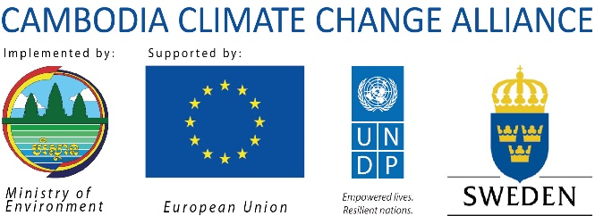
កម្មវិធីសម្ព័ន្ធភាពប្រែប្រួលអាកាសធាតុកម្ពុជា

Impact indicators for the CCCSP were under development when CCCA was launched.
Organisational, Financial, Operational, Environmental, Strategic, Regulatory, Security, Political, Other
2011, 2012 and 2013 CCCA Audit Reports

